 **Tools for Engaging All Learners**

**In the Classroom**

*Participant Manual*



Student Files (in course order)

State_Pop_Area_Data.xlsx

United_States_Outline_Map.docx

Europe_Map.pptx

State_Data.xlsx

North_Carolina.pptx

Pop_Density_Sort.xlsx

Area_Sort.xlsx

Population_Sort.xlsx

North Carolina_Final.pptx

Planet-Distance-Initial-Data.xlsx

Final-Race-ThreeSlides.wtt

Integration Project Files — Secretary of State

State_Pop_Area_Data.xlsx

United_States_Outline_Map.docx

State_Data.xlsx

Population_Choro_Legend.docx

Population_Choro_CmpltColor.docx

Population_Choro_CmpltGray.docx

Europe_Map.pptx

North_Carolina.pptx

North Carolina_Final.pptx

US_Pop_Map.jpg

Tobacco_Road_Video.wmv

* NC-State-Zune-Project_0001.wmv

NorthCarolina.wmv

Planet-Distance-Initial-Data.xlsx

Race-to-the-Planets-Complete.xlsx

Final-Race-ThreeSlides.wtt

MercuriusArtusQuelinus.jpg

VenusHead.jpg

UNCMarker.jpg

DukeMarker.jpg

NCSUMarker.jpg

Trademarks

Microsoft®, Windows® Vista®, Microsoft Office 2007®, Office Live Workspace®, Windows Live TM , Excel®, Word®, PowerPoint®, One Note®, Live Mesh®, Virtual EarthTM, Zune®, Movie Maker®, Microsoft Math®, World Wide Telescope®, and Sky Drive TM are either registered trademarks or trademarks of Microsoft Incorporated in the United States and/or other countries. Microsoft product screen shots are reprinted with permission from Microsoft Incorporated.

Disclaimer

While Knowledge Network Solutions, Inc. is conscientious in its efforts to ensure the accuracy of this student manual, no warranty is provided regarding the effectiveness, accuracy, or suitability of the material contained in this manual.

Copyright

This student manual is copyrighted by Knowledge Network Solutions, Inc. with al rights reserved. This student manual and any relevant student files may not be reproduced in any form or by any means without the prior written permission of Knowledge Network Solutions, Inc.

Table of Contents

Setting the Stage: Introduction 7

Setting the Stage: Introduction 8

What is Project Based Learning? 8

Explore: Discussing project-based learning 11

PC Based Applications 13

Explore: Navigating the Windows Environment 13

Explore: Using MS Office207 13

Explore: Microsoft Math 14

Explore: Windows Movie Maker 14

Explore: Windows Sound Recorder 15

Windows Live ID and Web Based Applications 16

Explore: Windows Live™ ID 16

Explore: Microsoft® Office Live 16

Explore: Live Mesh 16

Explore: Microsoft® Live Labs™ Photosynth 17

Explore: Microsoft® Zune™ 17

Explore: Microsoft® Virtual Earth™ 17

Explore: Microsoft® Research WorldWide Telescope 17

Test Your Knowledge 18

Curriculum Connections 19

Unit 1: Secretary of State Business Summit: Calculating and Using Data 21

International Business Summit 22

National Council for the Social Studies 23

The Instructional Plan: Secretary of State 24

Exploring Spreadsheets as Valuable Tools for Critical Thinking and Inquiry 29

Explore: Starting Excel and reviewing the Excel workbook window 29

Creating a New Population Workbook 31

Explore: Completing a population workbook. 31

Using the Fill Handle to Copy Population Density Formulas 34

Explore: Using AutoFill 34

Starting AutoFilter and Applying a Filter 36

Explore: Using and Applying AutoFilter 36

Using the Fill Handle to Change Each State’s Ranking 38

Explore: Data Fill and Color Shading 38

Explore: Color Shading 39

Creating the Choropleth Maps with Microsoft Word 41

Test your Knowledge 43

Curriculum Connections 44

Unit 2: Secretary of State Business Summit: Creating the New Media Exhibit 47

Creating a Short Presentation to Advertise and Highlight Your State 48

Adding a Picture and Notes to an Existing Slide 49

Explore: Inserting a Picture and Notes 49

Test Your Knowledge 50

Creating a PowerPoint to be Viewed at a Computer Station or on the Zune Media Player 51

Explore: Recording and Linking Voice Narration 51

Test Your Knowledge 53

Recording an Independent Sound File 54

Explore: Recording a Voice Narration to Sync with the Zune Media Player 54

Saving PowerPoint Slides as .jpg Images 55

Explore: Saving in Other Formats 55

Test Your Knowledge 56

Creating the Video File 57

Explore: Creating the Movie Maker Video 57

Synchronizing the Audio to the Video 60

Explore: Using the Slider Bar to Match the Audio Recording to the Images 60

Test Your Knowledge 61

Finishing the Video Project 63

Explore: Publishing the Video in Movie Maker 63

Test Your Knowledge 64

Synchronizing the Video with the Zune Media Player 65

Explore: Uploading Complete Media Files through Zune Software 65

Test Your Knowledge 66

Curriculum Connections 67

Unit 3: Secretary of State International Business Summit: Creating and Viewing 3-D Media 68

Using Microsoft® Virtual Earth 69

Explore: Creating a 3-D Tour 69

Test your Knowledge 73

Microsoft Live Labs Photosynth 74

Explore: Viewing the North Carolina Product in Photosynth 74

Curriculum Connections 77

Unit 4: Race to the Planets 79

Take a Tour of the Solar System with Microsoft Research WorldWide Telescope 80

Integration Project Learning Plan 81

Collecting, Analyzing, and Presenting Planet Data 83

Planet Data Collection 84

Explore: Collecting the Data and Completing the Calculations 84

Explore: Using the AVERAGE Function. 85

Creating Race to the Planets Presentation 88

Explore: Putting the Slide Show Together 88

Test Your Knowledge 91

Curriculum Connections 92

Unit 5: Another 21st Century Tool to Manage Your Work 95

Another 21st Century Tool to Aid Collaboration 96

Setting Up a Live Mesh Network 97

Explore: Navigating the Live Mesh Website 97

Explore: Accessing a Shared File on a Remote Desktop 100

Test Your Knowledge 101

Curriculum Connections 102

Unit 6: Project Review 105

Secretary of State Planning Grid 107

Putting it All Together 108

Explore: Thinking about the Benefits of Project Based Learning 109

MS Tools to Aid Project Based Learning 110

Explore: Selecting the Right Tool for the Job 110

Designing a Project Based Unit 111

Explore: Designing a Multi-disciplinary Project 112

Explore: Changing Classroom Practice 114

Next Steps 114

Appendix : Resources 115

Resources for Project Based Learning and Collaboration 116

Select Online Resources for Project Based Learning 117

References on Project Based Learning 119

Bibliography 122

Setting the Stage: Introduction

Course Objectives

To lead participants to enhance the learning process in all classrooms by engaging students in higher levels of thinking for project-based learning and problem solving.

To introduce participants to Microsoft products that engage learners in the learning process both inside and outside the classroom

To lead participants through discussions and activities to improve pedagogical practice and methodologies for the active, engaged learner

Setting the Stage: Introduction

Sit tight! Fasten your seat belts. It’s the 21st Century! Have you seen the new classrooms of the 21st century? There are no walls, no buildings, and no geographical limitations to accessing information. You probably already knew that, but did you know that collaborative student projects can also transcend those traditional barriers?

Microsoft® developed the tools. You can facilitate the projects!

What is Project Based Learning?

While “doing projects” is not a new concept in education, Project Based Learning (PBL) as a unique instructional methodology has emerged in only the past thirty years. With generally less structure than traditional teacher-led activities, PBL is known for its emphasis on student organization, time management, collaboration (often across disciplines), and construction of products (artifacts) to represent what is learned.

A generally accepted definition for Project Based Learning does not exist, but experts do agree that PBL is flexible and fits within a wide range of settings. Project implementation can range from a single subject area to across disciplines, from one classroom to broad community involvement, from students in a single grade level to adults outside the school, and any combination of these.

Project Based Learning for 21st Century Skills

Project Based Learning is one way for students to develop 21st century, those skills that business leaders and policymakers identify as crucial for a service-oriented, entrepreneurial, and global workplace:

* Higher order and critical thinking skills for problem solving.
* Communication in a variety of modes.
* Use of technologies to complete tasks.
* Ability to analyze, synthesize, and create. (Sawchuk, 2009)

Project Based Learning aids the development of 21st century skills by supporting multiple learning styles and intelligences, providing opportunities for cross-curricular connections, and addressing more than one standard within the framework of a single project. Students are also more likely to remember concepts because they engage in project management and investigate topics using multiple strategies. Your students will learn to apply skills and concepts rather than just memorizing them for a test (Stearns & Shay, 2008).

Elements of a Good Project Based Learning Experience

More important than a “one size fits all” definition for PBL is a description of what elements provide a good Project Based Learning experience for your students:

* Students are at the center of the learning process as recognition of their inherent desire to learn, their ability to do important work, and their need to be taken seriously.
* Students engage with the central concepts and principles of a discipline. The project work is central rather than incidental to the curriculum.
* Students investigate provocative issues or questions that lead them to in-depth exploration of real-world, important topics.
* Essential tools and skills, including technology, facilitate learning, self-management, and project management.
* Specific products that solve problems, explain dilemmas, or present information are generated through investigation, research, or reasoning.
* Projects yield multiple products that permit frequent feedback and consistent opportunities for students to learn from experience.
* Performance-based assessments communicate high expectations, present rigorous challenges, and require a range of skills and knowledge.
* Students collaborate in some form, either through small groups, student-led presentations, or whole-class evaluations of project results. (Markum, Mergendoller, Larmer, & Ravitz, 2003)

The body of research on Project Based Learning is growing and supports its use to cut absenteeism, increase motivation, and improve standardized test scores (Edutopia, 2001).

The Principles of Design in Project Based Learning

Planning for PBL is based on five dynamic principles, illustrated in Figure 1 below and briefly described in the following narrative.

**Design Principle #5:**

**Manage the**

**Process**

**Design Principle #2:**

**Develop the**

**Driving Question**

**Design Principle #1:**

**Begin with the**

**End in Mind**

**Design Principle #4:**

**Map the**

**Process**

**Design Principle #3:**

**Plan the**

**Assessment**

Figure 1. Design Principles of Project Based Learning

Design Principle #1: Begin with the End in Mind

Conceptualizing the project by its goal helps students understand the rationale and meaning behind what they are asked to do. They will retain more information, be more motivated to participate, and will be able to apply their knowledge more skillfully. Some examples of end goals you might identify may be a varied as those listed below.

* To create individual investment portfolios with accompanying business plans and product prototype.
* To educate the public about point source pollution.
* To understand the underlying causes of the Civil War. (Moursund, 2003)

Design Principle #2: Develop the Driving Question

Also referred to as the “essential questions, a good driving question addresses authentic concerns and focuses on the application of content within the real world. Good questions require students to draw upon content and personal experiences, lead to other questions posed by students, and are deliberately thought-provoking, counterintuitive, and sometimes controversial (Greece Central School District).

Design Principle #3: Plan the Assessment

Project assessments should come in multiple forms, with activities that are diverse enough to include all students, yet specific enough to provide relevant and meaningful evaluative information. Think about the process of triangulation:

* Multiple assessors. Students, peers, the teacher, and mentors.
* Multiple units of assessment. Individual students, groups, the whole class.
* Multiple formats. Written work (formal assignments and informal journal entries), observations (of group activities and individual work), presentations, informal discussions and questions, project designs, and the final media product (San Mateo Board of Education, 2001)..

In today’s PBL, many teachers allow students to help define the assessment strategies. The goal is for students to master the core content, conventions, and vocabulary of a topic.

Design Principle #4: Map the Project

Similar to a lesson plan, the project map helps you identify skills students need to perform, develop a timeline, and identify resources necessary to project implementation. The map includes the academic standards that summative test data reveal that students have not mastered. The teacher assumes the role of architect of student learning while mapping the project

Design Principle #5: Manage the Process

To manage the process, the teacher accepts a second role, that of the facilitator. As facilitator the teacher must be able to guide students through the learning process as well as keep the project focused and moving forward. You may have to learn or hone these skills as part of your own introduction to PBL.

Source, Figure 1 and Primary Source, Design Principle Information: (Buck Institute for Education and Boise State University, 2003)

Other Major Elements of Project Based Learning

There are several other major elements of PBL that you will want to include as you design your PBL unit. These include the following beyond the essential question: collaboration; communication; critical thinking; inquiry learning; synthesis. These elements are addressed individually during the four Microsoft EXPAND modules.

Explore: Discussing project-based learning

* List some projects that you currently have your students complete.
* List the skills that the students master by completing one of the projects.
* Do any of the projects involve opportunities for collaborative work?
* Are any of the projects long term projects?
* Do any of the projects address essential questions or introduce problems to be solved?
* Are the projects student-centered?
* Do any of the projects involve real-world issues or skills?
* How are the projects assessed?
* How would adding a technology component help the students better complete their projects? Better master the objectives?

PC Based Applications

Explore: Navigating the Windows Environment

Windows Vista and Vista Ultimate

Windows Vista® and Vista Ultimate® are the perfect choices for both personal and work use. Special features of Vista Ultimate® include enhanced search features, improved visualization capabilities, simplified maintenance, and advanced security features.

Explore: Using MS Office207

MS Office Word 2007

MS Office Word 2007® is a word processing program that alleviates the sometimes daunting tasks of handwriting, revising, and rewriting. Word provides tools such as cut and paste to move text with ease, delete to remove text with the push of a button, formatting tools and images to enhance the appearance of a document, and spelling and grammar checks. The Track Changes feature of Word enables multiple individuals to edit and contribute to one document. Another useful feature is the ability to view two separate documents side-by-side or different sections of the same document horizontally. MS Office Online® provides users with templates for many types of documents including to-do-lists, calendars, project organizers, greeting cards, certificates, resumes, and many others.

MS Office Excel 2007

MS Office Excel 2007® is a robust tool you can use to create and format spreadsheets or analyze and share information in a database format. You can use Excel to easily create and use professional-looking charts, which can interface with other Office products. Large amounts of data can be stored and manipulated with Excel through its 1 million rows by 16,000 columns, and built-in cell and table styles allow custom formatting. Excel also contains basic analysis tools such as sorting, filtering, and reorientation of data using pivot charts.

MS Office PowerPoint 2007

MS Office PowerPoint 2007® enables users to quickly create, share, and manage dynamic presentations. Use one of the stored or online slide templates, or create your own with the easy-to-use formatting options. Once created, presentations can be stored as individual slides on a site supported by MS Share Point® and their content used later to build new presentations. Power Point contains a library of document themes to enable users to change the look and feel of a presentation with just a click!

MS Office OneNote 2007

MS Office OneNote 2007**®** provides you a place to gather all your notes and information. It functions as a **digital 3-ring binder**. OneNote uses a powerful search engine and incorporates easily shared notebooks for more efficient **team and project management**.

OneNote offers flexibility not available with conventional paper-based systems (e.g., word processors, e-mail, or others), enabling the user to **gather and organize** text, pictures, digital handwriting, audio and video recordings, and more, in a digital notebook. OneNote 2007 can increase your productivity and reduce the time you spend searching for information by keeping **everything in one place** and at your fingertips.

Explore: Microsoft Math

Microsoft Math

Microsoft Math is both a teaching tool and a student tool. It provides a **Step-by-Step Equation Solver** that helps students solve simple and complex equations. The **Formulas and Equations Library** included in the on-screen calculator makes over 100 common equations and formulas readily accessible. Students easily convert different units of measurement using the **Unit Conversion Too**l.

Explore: Windows Movie Maker

Movie Maker

Import, edit, manage, and share your digital videos, including those images and videos captured in HD format. The easy and intuitive interface helps create compelling videos. Preview your video as you edit titles, credits, and transitions. You can build your own content or generate an **AutoMovie**.

Explore: Windows Sound Recorder

Sound Recorder

Using a quality headset or the built-into computer microphone create audio recordings with Vista **Ultimate ® Sound Recorder**. Import the audio into video using **Movie Maker** or have it stand alone.

Windows Live ID and Web Based Applications

Explore: Windows Live™ ID

Windows Live™ ID

A **Windows Live ID** allows you to use a single sign-on service to access all of the Windows Live web applications. You may choose to upload photos and files using the 25 GB **SkyDrive**, work collaboratively using **Live Workspaces**, or synchronize files across multiple devises with **Live Mesh**. You can share your files or keep them private.

Explore: Microsoft® Office Live

MS Office Live

Creation of a **shared workspace** using Microsoft Office Live**®** makes it easy to organize, manage, and share documents, notes, spreadsheets, presentations, contacts, to-do lists, and more. A project workspace can be used by students to collect and share key documents for their assigned tasks. Documents can be revised and then shared as separate versions. Other features make Office Live Workspace ideal for teamwork—such as e-mail notifications of activities, both locked and shared workspaces, project calendar and other useful templates, and ability to generate online comments.

Explore: Live Mesh

Live Mesh

After signing up for **Live Mesh,** you will be able to synchronize photos and files to your **Live Desktop.** Live Mesh comes with 5 GB of storage space. Add each device to your mesh and use a web browser to keep files updated. You can stop emailing files to yourself. Sync files across laptops, desktops, workplace computers, and mobile devices. This is a software services platform that builds on cloud storage and promotes collaboration and synchronization.

Explore: Microsoft® Live Labs™ Photosynth

Photosynth

After downloading Photosynth, get ready to create a 3-D, 360-degree visual experience. When taking photographs, overlap each image taken by at least twenty percent to create a Synth that places the viewer in your shoes as they view your experience. Photosynth builds a model of the photos’ location and recreates the display canvas.

Explore: Microsoft® Zune™

Zune™

Managing and synchronizing media is a breeze with the Zune™ media player and the Zune™ software. Download podcasts, video podcasts, music, audio books, video, or listen to FM radio.

Explore: Microsoft® Virtual Earth™

Virtual Earth™

Using Virtual Earth, you can take a “Bird’s Eye” trip through the Grand Canyon or your favorite city. You can create a 3-D tour video around the world or use Live Search Maps to find traveling directions.

Explore: Microsoft® Research WorldWide Telescope

WorldWide Telescope

Explore the universe using some of the highest resolution imagery in the web-based application WorldWide Telescope. You can use your computer as a virtual telescope to tour the planets or fly through the universe. After installing WWT, download guided tours or create your own tour of the heavens.

Test Your Knowledge

The tasks below were addressed in this unit. Be sure you understand the terms used and are able to complete the tasks listed.

Review Me – Identifying Application Platforms

1. List two Microsoft PC based application programs that you will explore.¬
2. _________________________________
3. ___________________________________
4. Name a Microsoft web based application.___________________________________
5. Which PC based application enables users to synchronize files across multiple devices? _____________________________________________________________

Review Me – Selecting the Correct Application

1. Which MS Office application is best for sorting data? _________________________
2. Which MS Office application functions as a digital notebook? __________________
3. Which application would be used for online organization? ______________________

Review Me – Understanding Project Based Learning

1. Create a working definition of project based learning. __________________________________________________________________________________________________________________________________________
2. List two ways you think technology aids to the success of project based learning

__________________________________________________________________________________________________________________________________________

1. How do you think project based learning helps those students who have learning difficulties?

__________________________________________________________________________________________________________________________________________

Curriculum Connections

Students use computers in the classroom as a tool for both productivity and learning. Integrating computer skills with the academic curriculum motivates and engages students, and prepares them for the technology age.

Below are a few ideas that can be used to integrate the skills covered in this unit into the academic curriculum.

**Idea 1 – Math Projects**

* Students investigate the mathematics involved in the construction of a kaleidoscope and make a model.
* How are math and statistics used in sports? Students track a team or league during a season, using a database to record, sort, and chart the data.
* Students use the Internet to study the history and use of the abacus. They build a model and develop a presentation using PowerPoint.

**Idea 2 – Science Projects**

* Students form teams to investigate and design a human settlement on Mars. Findings are presented in the form of a digital notebook.
* Student “delegates” to a world environmental congress gather and present data, online, on the global impacts of deforestation of the Rain Forest and make recommendations.
* Students examine real-world data on smoking and cancer and create an age-appropriate brochure for distribution to the middle school.

**Idea 3 – Interdisciplinary Projects**

* Math, science and social studies students complete a Chesapeake Bay Project (or any other body of water) to examine its history, ecosystem, and economic contributions to surrounding states.
* Science, language arts, and art students create a wildlife field guide of their local area.
* Science, language arts, math, social studies, and art students investigate popcorn. They explore why it pops, create a limerick about popping corn, use a database to record pre- and post- popping weight and volume, create charts and graphs, study popcorn as part of native American history, and create a picture using popcorn as the media.

Use the space below to write down additional curriculum connections ideas:

|  |
| --- |
|  |
|  |
|  |
|  |
|  |
|  |
|  |
|  |
|  |
|  |
|  |
|  |
|  |
|  |
|  |
|  |
|  |
|  |
|  |
|  |

Unit 1: Secretary of State Business Summit: Calculating and Using Data

Unit Objectives

Create a new Workbook

Learn to Write Formulas and Functions

Use the Filter to Reorganize Data

Repurpose Data Using the Fill Handle

Organize and Color Code Data

Create a Choropleth Map Using the Fill Shape Tool

Use Text Boxes to Create Map Legend

Publish the Choropleth Map as a Picture

Test Your Knowledge

Curriculum Connections

International Business Summit

Welcome to the International Business Summit. As the Conference convenes, students collaboratively embark on a technology-rich, project-based inquiry incorporating multiple disciplines to motivate and challenge their thinking. Collaborative Teams collect data that apply to each student throughout the project. In addition, each student assumes the role of an individual state’s business ambassador, the Secretary of State or a nation’s ambassador, representing a particular region of the country. For example, the North Carolina Department of the Secretary of State’s mission statement reads,

**MISSION STATEMENT:** To serve and protect citizens, the business community and governmental agencies by facilitating business activities, by providing accurate and timely information and by preserving documents and records.

Using the nationally recognized essential skills outlined by theNational Council for Social Studies, each student takes an active role in their learning by designing a campaign to promote the business opportunities of their state. Once the project requirements are established, the students use a model rubric to assist them in designing their assessment rubric.

Design teams of students use Microsoft Excel to analyze population data as they organize the data necessary to construct three choropleth maps of the United States in Microsoft Word. One map shows the relationship of each state’s population. The second map illustrates the square mile area of each of the 50 states. The final map shows the population density of each state. Some of the main questions each Secretary of State answers are: How then does each state’s population and population density rank affect that state’s chances for acquiring new business? How do the education opportunities in the selected state entice prospective entrepreneurs? Having become experts about their state, each Secretary of State uses different mediums to teach the Conference attendees about their state. Some of the Conference artifacts may include:

* A foam-board display advertising both statistical data and effective attributes of the state;
* A short PowerPoint for small group viewing;
* Dialogue with Conference attendees about the choropleth maps;
* PowerPoint video to use with Microsoft Zune and other mp3 players;
* A short survey/quiz for Conference attendees at the booth.

Guided by the National Council for Social Studies students actively practice growing their intellectual and social skills. Included in these skills are the critical thinking processes of classifying, interpreting, analyzing, summarizing, synthesizing, and evaluating.

This unit of study incorporates the best ideas found in collaborative and individual leaning practices. Students practice their teamwork, planning, and decision-making skills during this student-directed unit of study.

National Council for the Social Studies

Three strands of essential Social Studies skills:

* acquiring information;
* organizing and using information;
* developing interpersonal relationships and social participation.

The National Standards for Civics and Government include intellectual and participatory skills such as:

* influencing policies and decisions by working with others;
* articulating interests and making them known to key decision and policy makers;
* building coalitions, negotiating, compromising, and seeking consensus.

The National Geography Standards include the following skills:

* asking geographic questions;
* acquiring geographic information;
* organizing geographic information;
* analyzing geographic information;
* answering geographic questions.

The National Content Standards in Economics include the following skills:

* identifying economic problems, alternatives, benefits, and costs;
* analyzing the incentives at work in an economic situation;
* examining the consequences of changes in economic conditions and public policies;
* collecting and organizing economic evidence;
* comparing benefits with costs.

The Instructional Plan: Secretary of State

| KNS  For Standards-based, Student-centered, Technology-rich Learning | Teacher: | Grant Zimmerman |
| --- | --- | --- |
| School/District: | Chapel Hill-Carrboro City Schools |
| Subject Area(s) Addressed: | Social Studies, Language Arts, Math |
| Grade Level(s)/Course: | 4-12 |
| Date Submitted: | June 2009 |
| Lesson Duration: | 3-6 weeks; 1-2 hrs. per day |

|  |  |  |
| --- | --- | --- |
| Unit Title | Secretary of State | |
| Lesson Title | Creating choropleth maps | |
| General Lesson  Outcomes | The students gain a greater understanding of the importance of economics and geography. This unit of study arises from the idea that as each of the individual 50 states act in a way that promotes their common good, their actions also work to promote the common good of the country. | |
| **Academic Standards Addressed (List source & #)** | Social Studies Standards (North Carolina)  The learner will acquire strategies for reading social studies materials and for increasing social studies vocabulary.  **1.02** Summarize to select main ideas.  **1.03** Draw inferences.  **1.04** Detect cause and effect.  **1.05** Recognize bias and propaganda.  **1.06** Recognize and use social studies terms in written and oral reports.  **1.07** Distinguish fact and fiction.  **1.08** Use context clues and appropriate sources such as glossaries, texts, and dictionaries to gain meaning.  The learner will acquire strategies to access a variety of sources, and use appropriate research skills to gather, synthesize, and report information using diverse modalities to demonstrate the knowledge acquired.  **2.01** Use appropriate sources of information.  **2.02** Explore print and non-print materials.  **2.03** Utilize different types of technology.  **2.04** Utilize community-related resources such as field trips, guest speakers, and interviews.  **2.05** Transfer information from one medium to another such as written to visual and statistical to written.  **2.06** Create written, oral, musical, visual, and theatrical presentations of social studies information.  The learner will acquire strategies to analyze, interpret, create, and use resources and materials.  **3.01** Use map and globe reading skills.  **3.02** Interpret graphs and charts.  **3.03** Detect bias.  **3.04** Interpret social and political messages of cartoons.  **3.05** Interpret history through artifacts, arts, and media.  The learner will acquire strategies needed for applying decision-making and problem-solving techniques both orally and in writing to historic, contemporary, and controversial world issues.  **4.01** Use hypothetical reasoning processes.  **4.02** Examine, understand, and evaluate conflicting viewpoints.  **4.03** Recognize and analyze values upon which judgments are made.  **4.04** Apply conflict resolutions.  **4.05** Predict possible outcomes.  **4.06** Draw conclusions.  **4.07** Offer solutions.  **4.08** Develop hypotheses.  NCTM: Principles and Standards-Data Analysis and Probability Standards  Formulate questions that can be addressed with data and collect, organize, and display relevant data to answer them.  design investigations to address a question and consider how data-collection methods affect the nature of the data set;  collect data using observations, surveys, and experiments;  represent data using tables and graphs such as line plots, bar graphs, and line graphs;  recognize the differences in representing categorical and numerical data.  Select and use appropriate statistical methods to analyze data  describe the shape and important features of a set of data and compare related data sets, with an emphasis on how the data are distributed;  use measures of center, focusing on the median, and understand what each does and does not indicate about the data set;  compare different representations of the same data and evaluate how well each representation shows important aspects of the data.  Develop and evaluate inferences and predictions that are based on data  propose and justify conclusions and predictions that are based on data and design studies to further investigate the conclusions or predictions. | |
| **Technology Standards Addressed (List source & #)** | Technology Standards: (North Carolina)  The learner will acquire strategies needed for effective incorporation of computer technology in the learning process.  **5.01** Use word processing to create, format, and produce classroom assignments/projects.  **5.02** Create and modify a database for class assignments.  **5.03** Create, modify, and use spreadsheets to examine real-world problems.  **5.04** Create nonlinear projects related to the social studies content area via multimedia presentations.  ISTE NETS: Technology Foundation Standards for Students  Technology productivity tools  Students use technology tools to enhance learning increase productivity, and promote creativity.  Students use productivity tools to collaborate in constructing technology-enhanced models, prepare publications, and produce other creative works.  Technology communications tools  Students use telecommunications to collaborate, publish, and interact with peers, experts, and others audiences,  Students use a variety of media and formats to communicate information and ideas effectively to multiple audiences,  Technology research tools  Students use technology to locate, evaluate, and collect information from a variety of sources.  Students use technology tools to process data and report results.  Students evaluate and select new information resources and technological innovations based on the appropriateness for specific tasks.  Technology problem solving and decision-making tools  Students use technology resources for solving problems and making informed decisions.  Students employ technology in the development of strategies for solving problems in the real world. | |
| **Teacher-Led Activities (Introductory Lesson)** | The teacher will:   * Recognize each student as the Secretary of State and hand out the project guide, syllabus, presentation guideline, and model rubric. * Establish the goal of the International Business Conference: as Secretary of State, your mission is to, “To serve and protect citizens, the business community and governmental agencies by facilitating business activities, by providing accurate and timely information and by preserving documents and records.” * Explain that teams of students will work collaboratively to collect, analyze, and report on data common to each Secretary of State; e.g., population and area data. * Explain that individual students will collect and present data and information about their state during an International Business Summit attended by parents, members of the business community, and both state and local governments. * Review the projects syllabus and timeline. * With students, create a Student Calendar that establishes project checkpoint milestones. * In the Teacher Calendar, establish not only the student milestones, but prioritize the time needed to conference with the student teams using a Plus/Delta group-assessment. * In the Teacher Calendar, set times to meet with individual students and review their products. * After the first map is created, have students design a rubric for the remaining work. Mark in the Teacher Calendar time to revisit the Rubric Design. | |
| **Student-Centered  Activities** | * Students participate in the study of the **Secretary of State** Project guide, syllabus, presentation guidelines, and the model rubric. * Students select which state they want to represent. * Students, with the teacher’s coaching, form collaborative data collection teams. * In collaboration with the teacher, students construct a **Student Planning Calendar**. * Students will review the **Microsoft Excel** software and create columns to enter state data in alphabetical order. * Students practice statistical skills by finding mean, median, and mode. * Students practice math skills by finding the population density. * Review the spreadsheet processes of: data fill, copying, cutting, pasting, undo typing, color fill, adding and using filters, entering formulas, and entering functions. * Students upload their shared files to **Windows Live Workspace**. * Students upload their files to **Windows Live Mesh** to synchronize the files with their home system. * Students use **Microsoft Word** to create three choropleth maps, with a legend, using the fill shape tool with the corresponding colors from the generated data. * Collaborative teams meet to design the project assessment rubric. * Collaborative teams conference with the teacher using a Plus/Delta performance assessment tool. * Each Secretary of State individually completes the remaining products from the **Project Planning Grid.**   The original collaborative teams meet to review the established performance milestones from the **Student Planning Calendar**.  Students review the processes associated with constructing a **Microsoft PowerPoint** slide show.  Students prepare backboard to display maps, lists, pictures, text, other paper generated information.  Students construct 10-15 slides advertising and highlighting their states geography, institutions of higher education, roads, history, and other important attributes of the state. Each slide will contain information to use as the voice over text.  Students save the **PowerPoint** as JPEP images.  Using **Windows Movie Maker**, students create a montage of stills with an informational voice over. Students publish the video and synchronize it to the **Microsoft Zune**.  Using **Microsoft Virtual Earth**, students create a short 3-D tour of an important state attribute. This video is synced with **Zune**.  Students practice their presentations by reviewing both **Zune** synced videos.  Students take 10-15 photos of a major state product following the **Photosynth** guidelines. These guidelines suggest that 20% of each picture overlap the previous picture.  Students create and send invitations to parents, business leaders, along with local and state government officials.  The original collaborative teams construct announcements to send to prospective attendees. These announcements should be both electronic and print.  Students create a survey for the attendees. Ask the question, “After viewing, listening, and discussing the information provided, which of the North Carolina’s attribute do find to be most important in start and grow you business in our state?” Each student adds four multiple-choice questions to the survey that speak to the information presented. | |
| **Resources Needed** | Content resources (books, articles, speakers, handouts, materials, etc.) | Software/Web Resources (CD-ROMs,URLs, etc.) |
| Social Studies Textbook  Project Planning Grid handout  Public presentation guidelines  Backboard guide  Schedule room for the Conference  Pertinent State product images  (Images used for the North Carolina Secretary of State Project are provided by and used with permission from the, NC Office of Archives and History, [www.ncmarkers.com](http://www.ncmarkers.com)) | Microsoft® Office 2007  Zune software installed (free)  Windows Live ID (free)  Windows Live Workspace (free)  Window Live Mesh (free)  Windows Movie Maker (free)  Windows Virtual Earth (free)  Windows Photosynth (free)  <http://www.infoplease.com/us.html>  <http://www.50states.com/>  <http://www.50states.com/maps/>  <http://www.globalcomputing.com/states.html> (information links to all 50 states)  <http://www.ncpublicschools.org/curriculum/socialstudies/scos/2003-04/017skillsk5>  <http://www.stanford.edu/class/linguist34/>  <http://home.olemiss.edu/~egjbp/comp/ad-claims.html>  <http://www.ncmarkers.com> |
| Hardware (computers, TV, DVD, etc.) | Other media, video, satellite, etc. |
| Computers  Notebook or Mini-book computers if available  Zune™  High-speed Internet access  Tables  Camera |  |
| **Student Assessment Strategy** | Collaboratively (students and teacher) designed 4-5 column rubrics.  Periodic Plus/Delta self-assessment conferences. | |

Exploring Spreadsheets as Valuable Tools for Critical Thinking and Inquiry

Explore: Starting Excel and reviewing the Excel workbook window

Windows Vista Ultimate

Windows Office 2007

1. Click the Start button (the Windows circular icon in the lower left corner). In the search box, begin to type Excel. From the Programs section of the menu, select Microsoft Excel 2007 from the list. Alternative method – In the START SEARCH section just above, type Excel. The program will be listed immediately for you to click.
2. Click open. See the figure below.
3. Observe the Excel workbook window displayed on your screen. It should be similar to the figure below. Important features have been identified in the Excel window for you.

Ribbon

|  |
| --- |
| OpenExcel1.gif.  Cell  E7  Group |

1. Review these features so that you are able to refer to them as you use the software with your students. Some specific uses of several of these features are:

* **Office Button.** Click the Office Button to open files, save, print, and see other things you can do with your documents.
* **Quick Access Toolbar.** Allows you to display tasks that you use frequently that are “hidden” under the various Menu Bar tabs. To add tasks to the Quick Access Toolbar, click the down arrow to the right of the last task that you see. On the example window above, the last task shown is the “Open File” icon.
* **Menu Bar.** The Menu Bar contains seven expandable tabs: Home, Insert, Page Layout, Formulas, Data, Review, and View. Each tab is expandable—when you click it, various sub-tasks are displayed on a **Ribbon** below the Menu Bar.
* **Ribbon.** Each ribbon associated with a tab on the Menu Bar contains tasks that are regularly performed in Excel. If the various sections of the ribbon show an arrow in the lower right corner, additional tasks are available by clicking the arrow.

Creating a New Population Workbook

Once the Secretaries of State have chosen their state and participated in the review of the project guidelines, syllabus, presentation procedures, and the model rubric, the hunt for population and area data begins. Organizing the information into a spreadsheet is a helpful way to prepare for analyzing and manipulating the geographical data.

The Secretaries of State gather in collaborative research pairs to locate and enter the geographical data. When the file is opened, students recognize the state of Alabama holds the upper alphabetical position. Students enter the information that matches the alphabetical list of states. Not only do Excel workbooks organize state information this way, but also entering the information according to a list in which Alabama holds the ordinal position of #1 gives opportunities to filter the data during follow-up sessions to students. In this session, students will:

* Enter data;
* Write formulas and functions;
* Filter the data;
* Repurpose data using the Fill Handle;
* Organize and color code the data.

Explore: Completing a population workbook.

Microsoft® Excel

1. 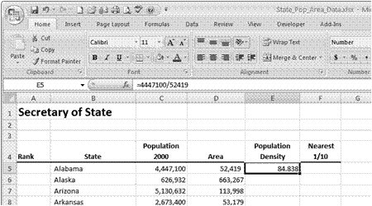Open the file State_Pop_Area_Data.xlsx. (Your instructor will guide you to the location of class files.)

**Formula Bar**

1. This file contains each state’s population and the number of square miles. You will write and apply formulas to calculate the population density, round the population density to two decimal places, add the Filter Bar to the data, reset the ordinal position of the states, logically group the data into seven categories, and color code each of the seven groups.
2. Click cell E5.
3. Enter (without the commas) =4447100/52419
4. Press Enter.
5. The formula is calculated and the results are entered in cell B5.
6. To observe the formulas, click to make cell E5 active and view the *Formula Bar*. It should appear as in the figure at the right.
7. The results of the calculation are shown in the cell, but the formula is displayed in the Formula Bar.
8. Another method for entering the formula for population density is to use the cell reference rather than the actual values. You will use this method for the next cell.
9. Select cell E6 and enter =C5/D5.
10. Observe the cells that have been referenced. Excel marks each cell with a different colored border that corresponds to the cell reference in the formula. This is Excel’s way of asking you to check, “Are these the values you want to divide?” before calculating the formula.
11. Press Enter or click the check mark in the *Formula Bar* to perform the calculation.
12. An advantage of using cell references in formulas is the ability to recalculate automatically when changes are necessary. There are two ways to edit the formula. Changes can be entered into the Formula bar, or the cell’s value can be changed directly in the cell, each altering the calculation. When making changes to the values, Excel automatically recalculates them.
13. To view the formula again, make E6 active and observe the *Formula Bar*.
14. Select cell C6 and replace the population value with 500000.
15. The formula automatically recalculates.
16. On the **Quick Access Toolbar**, click the Undo icon,undo.gif, to return to the original population.
17. Select cell E7.
18. Excel has shortcuts to make the calculating process simpler.
19. Either in the selected cell on in the formula bar after you have selected the cell, type **=** and then click cell C7. Cell C7 has been added to the formula.
20. Type **/** and then click cell D7. The contents of cell D7 has been added to the formula.
21. Press Enter. The Population Density calculates.
22. Save this file as State_Pop_Area_Date_1.xlsx .

The population spreadsheet includes a column of data that needs to be calculated. Finding the population density involves dividing each state’s population by the number of square miles for that state. Excel uses two main methods to enter values needing calculation:

* Absolute data entry—enter numbers as you would enter them using Microsoft Math Calculator
* Relative data entry—enter the cell references containing the values to be calculated

Hence, using the Math calculator the number sentence showing Alabama’s population density, the number of people per square mile, looks like this:

* Type, **4,447,100 ∕52,419 =** 84.84 (rounded to the second decimal place)

In **Excel**, the number sentence looks just a little different:

* Type, **=4447100/52419** press Enter.

Typing the actual numbers into cells to be calculated uses the absolute cell entry method. You want only those values calculated.

All formulas begin with typing the equal sign. Using the relative method of entering values needing calculation allows us to copy that formula to other cells and let Excel manage which cells to calculate.

In the previous lesson, we also used the **relative** cell entry method for calculation. That is:

in cell E6 you either typed **=C6/D6**

or, you used the mouse pointer and

typed the **equal sign** clicked cell C6, typed the division operator, clicked cell D6, and then pressed Enter.

Using the Fill Handle to Copy Population Density Formulas

Explore: Using AutoFill

To fill adjacent cells quickly **and** have Excel to manage the calculations using new cell referenced values, enter the formula by typing the cell reference or enter the formula by clicking the cells you want to calculate. ***Remember*** to start each formula with an equal sign

1. If necessary open the State_Pop_Area_Data1.xlsx file and select cell E6 (=).
2. You will copy this formula to rows E7 through to E54.
3. Place the mouse pointer in the center of the active cell.
4. You will see the white cross pointer, used to select cells or ranges.
5. Move the mouse pointer to the Fill Handle located in the lower right corner of the active cell.
6. When placed in the correct position in the corner, the pointer changes to a smaller black cross.

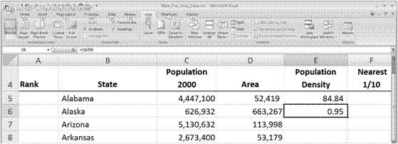

1. Press and hold the mouse button.
2. Drag to cell E54 and release.
3. The population density formula has been copied to each cell and the cell references have been adjusted to reflect the new location of the formula.
4. **Note:** Depending on your operating system you may see a small drop-down menu appear below cell E54. It contains several **AutoFill** options. Make certain that the radio button by **Copy Cells** is selected.
5. Click to deselect the cells, and then click cell E54.
6. The formula in the Formula Bar displays references the calculation of cells =C54/D54 .   
     
   Using the Fill Handle/Auto Fill Options to copy and perform functions is a helpful tool for calculating efficiently in a worksheet.
7. Save to update and close the file.

Starting AutoFilter and Applying a Filter

To query is to ask a question to retrieve specific information from a database. The Secretary of State worksheet is an Excel spreadsheet and an Excel database.

You will use the automated filtering tool called **Filter** to sort and resort the data. Each Secretary of State will use the sorted date to create three different choropleth maps.

* Population choropleth map using seven colors
* Area choropleth map using seven colors
* Population Density map using seven colors

After applying the **Filter, you will rank the state’s position in the group using ordinal numbers. Then using each state’s rank, the collaborative team will analyze the data and choose logical divisions to separate the date into seven different groups. Each group is color-coded. Use these same colors to shade each of the 50 states. The shaded-area map produces a choropleth map.**

Explore: Using and Applying AutoFilter

1. Open State_Pop_Area_Data1.xlsx .
2. Select a cell within the data table.
3. Choose the Data tab. Move to the Sort & Filter group and then click the Filter icon.
4. This action turns on the Filter feature of Excel. Notice the drop-down arrows that now appear to the right of every field name (titles) in the data table.
5. Click the drop-down arrow for the Population 2000 field.
6. Select Sort Largest to Smallest.
7. This action filters the data according to the selected criteria. California attains the number one position in the ranking and Wyoming moves to the last position.

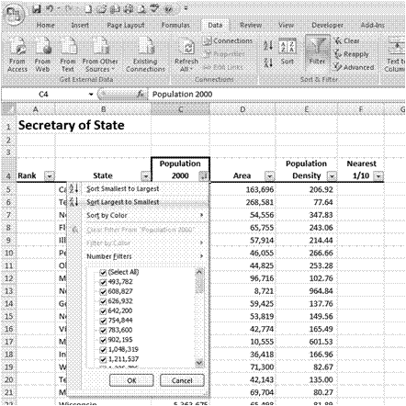

Filtering **Population 2000**

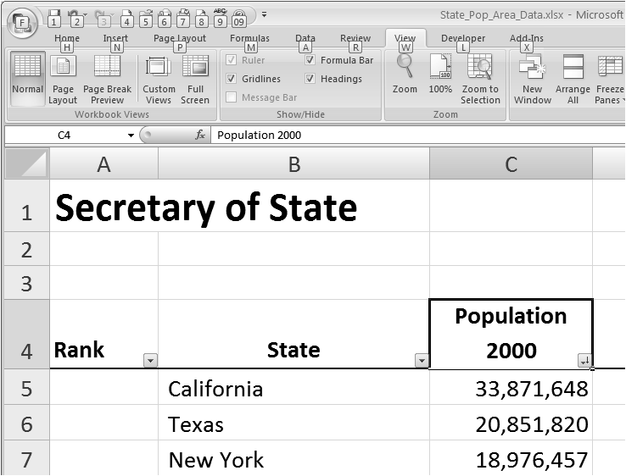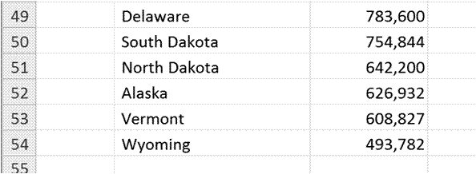

Position # 50

Position #1

1. Save this file as Population_Sort.xlsx.
2. Perform similar filtering to the **Area** field.
3. Select the Filter Button in the **Area** field and choose Sort Largest to Smallest.
4. Save this file as **Area_Sort.xlsx.**
5. Select the Filter Button in the **Population Density** field and choose Sort Largest to Smallest.
6. Save this file as Pop_Density_Sort.xlsx.

Using the Fill Handle to Change Each State’s Ranking

For each of the three databases you will rank the states according to their position in the table. Because you sorted the data from largest to smallest, the uppermost state will be in the number one position. For each worksheet, you will:

* Change the state’s ranking
* Collaboratively analyze the data, selecting seven logical divisions
* Assign a color to each of the seven divisions
* Use the Font-Fill Bucket to fill each row.

Explore: Data Fill and Color Shading

1. Open the file State_Data.xlsx.  
   This file contains the four worksheets we will use in one file.
2. At the bottom of the worksheets are Tabs. Click the Tab titled Pop Sort .
3. Point the mouse pointer to cell A5 and click cell A5 . Type the number one in cell A5. Press Enter .
4. 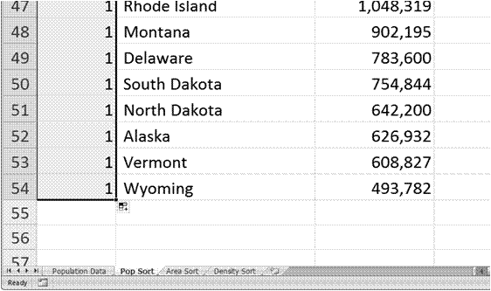Return the mouse pointer to cell A5. Move the mouse pointer to the small black box at bottom right corner of cell A5.
5. When you have placed the mouse pointer correctly, a small black cross figure will hover over the bottom right corner.

**AutoFill Options** box

1. Grab the cross and pull it down to cell A54 .
2. You will notice a small box showing a right angle grouping of cells surrounded by a dotted line.
3. Click the Arrow on the right of the AutoFill Options box.
4. Select the radio button that says Fill Series .
5. This will fill the column with the number 1-50. Ranking each state’s population from greatest to least is achieved.
6. Save this file as State_Sorted_Data.xlsx.
7. 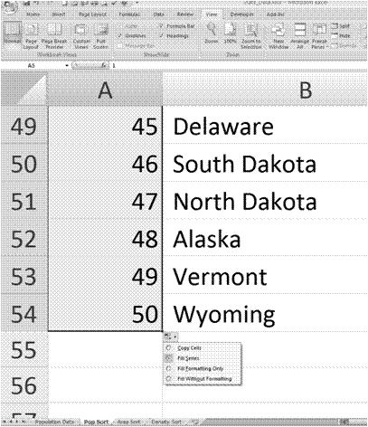Repeat this process for each of the remaining worksheets:  
   Worksheet: Area Sort and Worksheet: Density Sort
8. Save this as State_Sorted_Data.xlsx.

**AutoOptions**

**Fill Series**

radio button

Explore: Color Shading

Select a partner. Each two person collaborative team will analyze and logically identify seven logical groupings using the sorted population, area, and population density data. These same colors are used to create the choropleth maps.

1. Have the file **State_Sorted_Data.xlsx** open.
2. Place the mouse pointer in cell A5 . Hold down the left mouse button and drag the mouse pointer across to cell C5.
3. With the row A5:C5 highlighted, in the Font group click the Fill button .
4. Click your chosen color . Repeat the process for the remaining six groups.

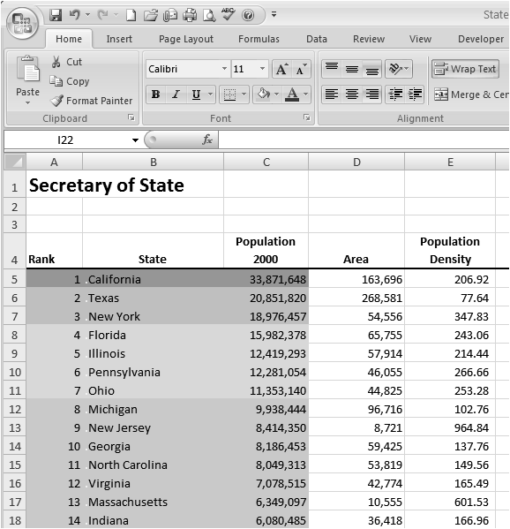

Population Groups

**Fill Bucket**

1. Save the file.

Creating the Choropleth Maps with Microsoft Word

Choropleth maps incorporate a uniform color pattern within like spatial units. These maps are useful for increasing your understanding of the related data sets. For example, coloring the state of California with one color and the next two most populous states with a different color distinctly shows major differences in population. Choropleth maps show relationships of spatial data sets.

1. Open the Word file UnitedStatesOutlineMap.docx.
2. Move the mouse pointer to California and click the state.
3. California opens as a .jpg image. It can now be filled.
4. Click Format Tab located under Drawing Tools on the Menu Bar. Select the arrow for Shape Fill. Click the color your team has chosen. Alternately, click one of the Shape Style Colors that matches your team’s decision.
5. Choose the color that you used in the Excel file.
6. Move to the next group of states and repeat the Fill process.

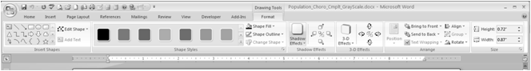

**Shape Styles**

**Drawings Tools**

**Format Tab**

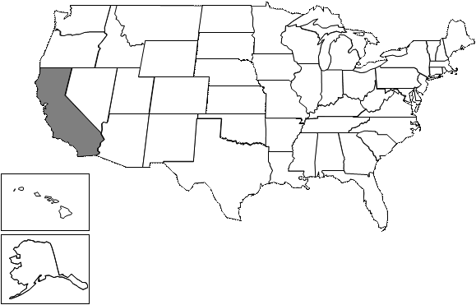

**Shape Fill**

1. Save the file as Population_Choropleth.docx.
2. Open the file Population_Choro_Legend.docx.
3. Click the Insert tab. Move to the Text group and click the Text Box arrow.
4. At the bottom of the dialog box, click Draw Text box.
5. The familiar Crosshair will appear. Move the crosshair to the Population Legend and draw a text box to hold the color matching the group population data set.
6. Fill the text box with the appropriate color. Finish creating the Population Legend.
7. Save the file Completed_Pop_Data_Map.docx

Test your Knowledge

The tasks below were addressed in this unit. Be sure you understand the terms used and are able to complete the tasks listed.

* Entering an Absolute formula
* Entering a Relative formula
* Using the Fill Handle to Copy
* Using the Fill Handle to Fill a Column with ordinals
* Using Fill Shape in Excel and Word
* Creating Text Boxes

Review Me – Entering and copying formulas

1. Open State_Data.xls and click on the Europe worksheet.
2. Type these country’s names, populations, and areas:
3. Ǻland (Finland)—26,008—1,552
4. Albania—3,600,523—28,748
5. France—59,765,983—547,030
6. Click cell E4 . Type the equal sign to begin a formula. Click cell C4 , type the division sign , click cell D4 and press Enter.
7. This action writes a relative formula finding the Population Density in cell E4.
8. Use the Fill Handle to copy the formula through to France.
9. Save the Excel file.
10. Open the PowerPoint file, **Eurpoe_Map**.pptx.
11. Click on the **Europe** map to open the images.
12. Click on France, click Drawing Tool—Format Tab, and select a color to fill the country.
13. Save the PowerPoint file.

Curriculum Connections

Students use computers in the classroom as a tool for both productivity and learning. Integrating computer skills with the academic curriculum motivates and engages students, and prepares them for the technology age.

Below are a few ideas that can be used to integrate the skills covered in this unit into the academic curriculum.

Idea 1 – Median Housing Prices

* Group students into small collaborative groups.
* Research and collect median housing price data.
* Create a spreadsheet to analyze and calculate the data.
* Create a choropleth map showing the range of housing prices across the country.

Idea 2 – Range of Elevation

* Research and collect the highest and lowest points of elevation.
* Create a spreadsheet to analyze and calculate the data.
* Create a choropleth map showing the ranges in elevation.

Idea 3 – Date State Admitted to the Union

* Research and collect the dates each state was admitted to the Union.
* Use the Filter command to sort the dates.
* Create a choropleth map.

Use the space below to write down additional curriculum connections ideas:

|  |
| --- |
|  |
|  |
|  |
|  |
|  |
|  |
|  |
|  |
|  |
|  |
|  |
|  |
|  |
|  |
|  |
|  |
|  |
|  |
|  |
|  |

Unit 2: Secretary of State Business Summit: Creating the New Media Exhibit

Unit Objectives

Inserting a Picture

Inserting Notes

Inserting Recordings

Setting Timings

Save PowerPoint as .jpg images

Creating a Video

Synchronizing Video to Zune™ Media Player

Test Your Knowledge

Curriculum Connections

Creating a Short Presentation to Advertise and Highlight Your State

Students are savvy users of media. They approach the task of adding multimedia resources to their projects with much enthusiasm. Following the Secretary of State Planning Guide, students begin their thinking about what to include in the short, 10-15 slides, PowerPoint presentation. Students use the Guide to help them build the PowerPoint storyboard. Teams should collaborate on the initial design structure and create a rubric to assess their work. After the design teams agree on the design and rubric, each Secretary of State team constructs their presentation that advertises and highlights the state they represent. This is a good time to teach your students a few principles of good design.

Even though PowerPoint slides may incorporate animation and include multimedia examples, their underlying structure shares the same design and art techniques used to create print advertisements. Understanding how human behavior is influenced by advertising helps students build a richer state presentation. After all, it is the job of the Secretary of State to promote his/her state’s qualities, and thereby, garner more business investment.

Have students collect and bring to class numerous examples of print advertisements to study. In small groups, have the students first find the center of the advertisement. Draw lines connecting opposite diagonal corners. The center will be where the two lines intersect. Acknowledging the center places the rest of the advertisement in perspective.

Have each group ask and answer the following questions about the print advertisement:

* How does the ad communicate its purpose?
* How does the advertisement use color to capture your interest?
* How does the text add or detract from the message?
* What messages are delivered by the advertisement not directly stated by the text?
* Identify the kinds of persuasive techniques applied in the advertisements such as

bandwagon, testimonials, repetition, transfer, name-calling, glittering generalities, deck stacking, and snob appeal.

The students will build a PowerPoint that uses the principles of good design while highlighting the advantages of selecting your state for new business investment. You will want to include examples of the following:

* Institutions of higher education
* Geography
* Transportation
* Entertainment
* History.

Adding a Picture and Notes to an Existing Slide

Microsoft® Office defines pictures as any type of graphic image acquired from a source, rather than created using drawing tools. To add pictures and other graphic images, you can use the **Insert** tab, **Picture** command. Selecting **Insert, Picture…**, by default, opens up the Insert Picture dialog box and the Documents/ Pictures folder on your hard drive. You may navigate to any location from the Insert Picture dialog box, select the file and click **Insert**.

When pictures are inserted to the slide, the Picture Tools—Format tool bar appears with options to modify the picture’s appearance and size. Adjusting the picture’s contrast or brightness, compressing the picture file size, and cropping unwanted edges are a few of the choices.

Explore: Inserting a Picture and Notes

Microsoft Office 2007 PowerPoint

1. Open **North Carolina.pptx**. Display slide 4.
2. You will insert the population choropleth map.
3. Click the Insert tab and select Picture.
4. Browse to your class files and select USA_Pop_Map.jpg.
5. After selecting the picture, click Insert.
6. The picture is inserted into the slide with the white background in which it was created.
7. Resize and reposition the picture as needed.
8. If necessary, select the Picture Tools—Format tab. Choose a picture style from the **Picture Group** that is pleasing to your eye.
9. From the Picture Tools—Format tab ribbon, **Adjust** group, click the **Contrast** icon. Experiment with several levels to reach the contrast you prefer.
10. Picture files can be very large and slow down the momentum of the presentation. In the same **Adjust** group, click Compress Picture.
11. Choose Apply to selected pictures only, click Options.
12. In the **Target options**: sections, choose Screen.
13. Leave the **boxes checked** for
14. **Automatically perform basic compression on save** and
15. **Delete cropped areas of pictures**.
16. Click OK.
17. In the Notes section at the bottom of the slide, add a sentence or two that explains the choropleth map.
18. Use these notes, as your script, to record a narration for the PowerPoint. The Conference attendees will watch and hear the presentation in the kiosk playback setting.
19. Save the file.

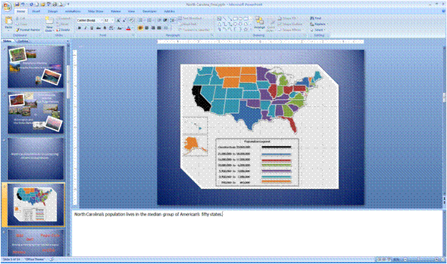

Notes Area

Test Your Knowledge

Create a short; three slide PowerPoint that highlights one attribute of your selected state.

1. Include a Title slide, an Attribute slide, and a Closing slide
2. Be sure to practice the following skills:
   * Inserting a picture;
   * compressing a picture;
   * changing the picture style;
   * adding text to the slide;
   * creating script notes to use for the voice narration.
   * Save the file with the name of, [Your Name]MyState-Practice.pptx.

Creating a PowerPoint to be Viewed at a Computer Station or on the Zune Media Player

Each Secretary of State will create a short PowerPoint showing the attributes of the state they represent that includes a voice narration. This way the slide show can be viewed in the repeating kiosk setting. Following a few steps, creating a voice narration is an uncomplicated task. You click the Slide Show tab, click Record Narration, set the Recording Quality, Link the narrations to the PowerPoint file with a check mark, and begin recording the narration.

To record a smooth presentation, prepare and practice the script before recording. Write the script under each slide in the Notes section. Print a copy of the notes and the slides. Read the notes clearly as you record the narration.

You will record the narration a second time using Windows Voice Recorder. You will input the .wav narration file and a stack of .jpg images into Windows Movie Maker. Once imported, synchronized, and saved, the video file will be uploaded to the Zune™ Media Player.

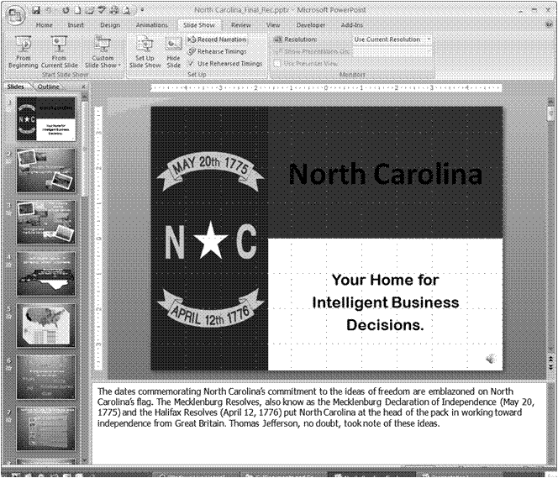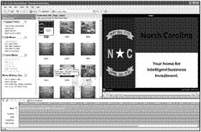

Explore: Recording and Linking Voice Narration

Office 2007 PowerPoint

1. Open the[Your Name] MyState-Practice.pptx PowerPoint file you created in the Test Your Knowledge section.
2. Click Slide Show tab.
3. Click Record Narration.
4. Click Change Quality.
5. This changes the audio recording quality from the default low quality recording to the much higher, CD quality, stereo recording.
6. Move the mouse pointer to the Name selection box and click the arrow.
7. 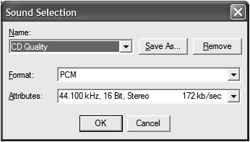Select and click CD Quality.
8. This changes the recording frequency to 44.100 kHz, 16 bit, Stereo, 172 kb/sec.
9. Click OK.
10. Click the check box next to Link narrations in:

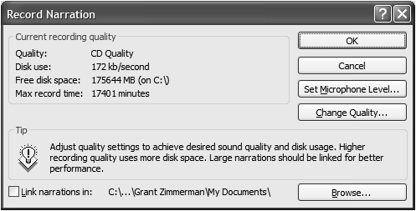

Click the check box to link your narrations to each slide in the PowerPoint file.

C:\Documents and Settings\Grant Zimmerman\Local Settings\Temporary Internet Files\Content.IE5\Z286HB6X\MCj04325300000[1].png

1. Click Set Microphone Level and read the sentence to adjust the microphone level.
2. Adjust the volume control as needed.
3. Click OK.
4. Be ready to begin reading your scripted notes. When you click OK on the Record Narration dialog box, PowerPoint asks whether you want to begin recording from the Current Slide or from the First Slide.

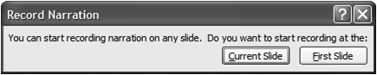

1. Click OK on the Record Narration dialog box.
2. Click the First Slide to start recording.
3. Read the script in a clear, moderately paced voice. If you read too quickly, the message may be clipped and render a partially garbled narration. You can always re-record your narration.
4. Note: Re-recording for a Specific Slide
5. If you want to re-record a narration for a specific slide, move to the slide and click that slide. Choose Record Narration, make the necessary Change Quality settings to CD Quality, and click OK.
6. Choose to record to the Current Slide.
7. Save the file as [Your Name]MyState-Practice-Voice.pptx.

Test Your Knowledge

The tasks below were addressed in this section. Be sure you understand the terms used and are able to complete the tasks listed.

Test Your Knowledge Review

1. Recording PowerPoint narration.
2. Write a new script for one slide, or add to the script of a current slide.
3. Record a new narration for the current slide.
4. When you start recording, click the record from Current Slide.
5. Save the file with a new version number, such as, [*Your Name*]**MyState-Practice-Vocie2.pptx**.

Recording an Independent Sound File

Windows Sound Recorder®

Explore: Recording a Voice Narration to Sync with the Zune Media Player

You will use the skills practiced in the previous Explore activity to record the **same script** using **Windows Sound Recorder**. Use the three-slide script contained in the notes section of [*Your Name*]**MyState-Practice-Voice.pptx.**

Each Secretary of State will later import and synchronize the Windows Media Audio file with the imported .jpg images from the PowerPoint slides. Later, these synchronized files are saved as a video and uploaded to the Zune Media Player.

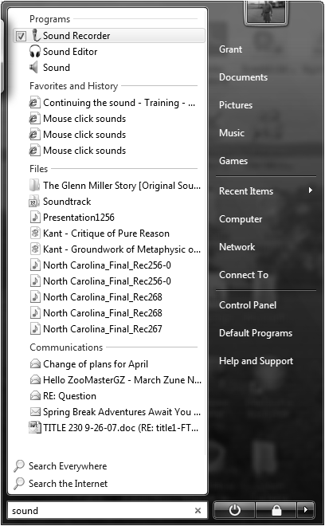

1. Click the  Vista Start button in the lower left corner.

Type sound recorder in the search box.

As soon as you click the Start button, Vista enters characters you type into the Search box.

1. Begin typing sound recorder.
2. This new feature in Vista searches for the most likely candidates that meet your query after entering the first few characters.
3. Click Sound Recorder. It is located at the top of the **Programs** list.
4. Have your script ready. Remember to read in a clear, moderately paced voice. Include in your reading the appropriate inflection and enthusiasm.
5. Click Start Recording and begin reading the script.
6. 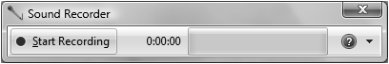
7. When you have finished recording, click Stop Recording.
8. 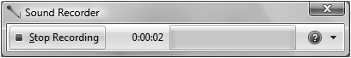
9. Type, [Your Name]MyState-Practice-Zune-Voice in the **File name:** box.
10. Navigate to the folder in which you want to save the file.
11. Click Save.
12. The file is saved as a Windows Media Audio (*.wma) file.

Saving PowerPoint Slides as .jpg Images

Explore: Saving in Other Formats

1. Open the PowerPoint file, North Carolina_Final_Rec.pptx.
2. Click the Obutton.gif Office 2007 button in the upper left corner.
3. Navigate to the Class Files folder.
4. Click Save As and click Other Formats.
5. Click the arrow to the right of the Save as Type: box. Scroll down and click .jpg (File Interchange Format).

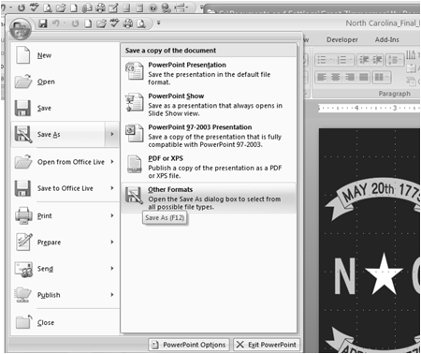

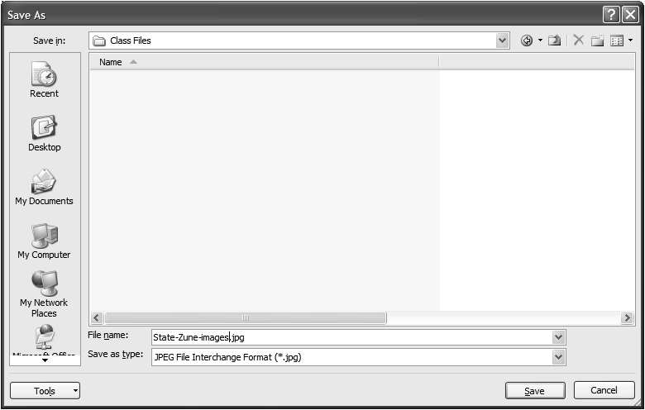

Select the Save as Type format by clicking the arrow.

1. Type State-Zune-images in the **Name:** box.
2. Office 2007 automatically adds the filename extension (.jpg) to the each slide.
3. Click Save.
4. Click Every Slide.

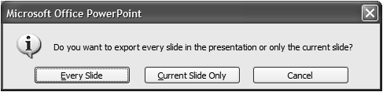

1. PowerPoint creates a new folder in Class Files named **State-Zune-images**. This folder contains the sequentially numbered .jpg images of each PowerPoint slide.
2. Click OK.

Test Your Knowledge

Use this section to review the skills in the previous Explore section.

Test Your Knowledge- Create an Image Folder for Your Practice State PowerPoint

1. Open the PowerPoint file named, [Your Name]MyState-Practice.pptx
2. Click the Office button, and then move the mouse pointer Save As.
3. Click Other Formats.
4. Click the arrow to the right of save as type: and click .jpg.
5. Type a new filename, [Your Name] MyState-Practice-images1.
6. Click Save.
7. Click Every Slide



1. Click OK.

Creating the Video File

Using Windows Movie Maker, each Secretary of State will import and synchronize two files: **the image/slide file** and the **independent voice narration Windows Media Audio file.**

Windows Movie Maker

Explore: Creating the Movie Maker Video

1. Click the Vista.gif Vista Start button and type movie maker.

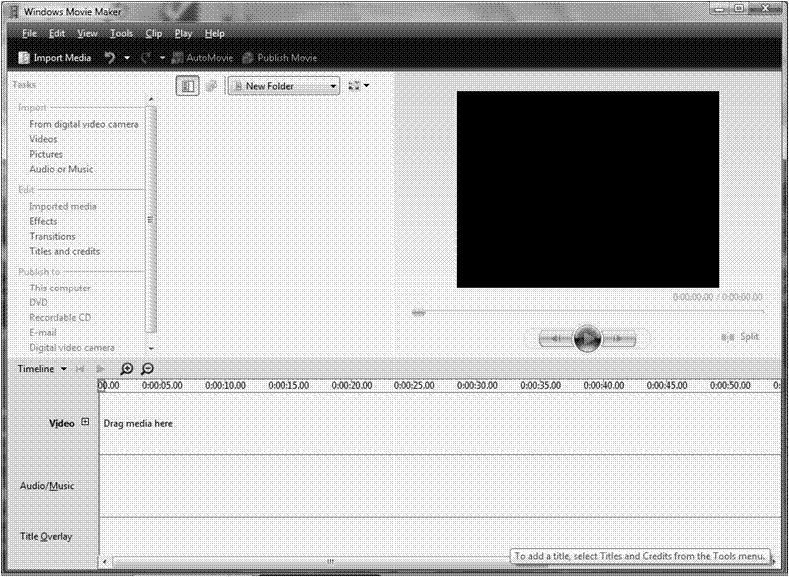

1. Click the program Windows Movie Maker.
2. Under the **Import Task title**, click Pictures.
3. Navigate to the Class Files folder and double click, to open the State-Zune-images folder to locate the images you saved as **State-Zune-images**.
4. Click Organize in the toolbar to open a drop down dialog box.
5. Click Select All. A check mark is placed at the top left of each and select every image.

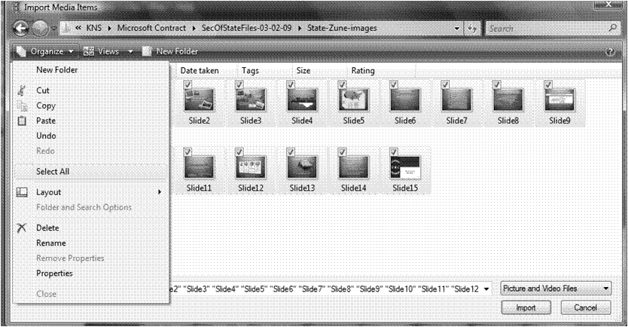

1. Click Import.
2. Use the **vertical slide bar** to show Slide #1.
3. Click Edit on the top toolbar. Locate and click Select All.

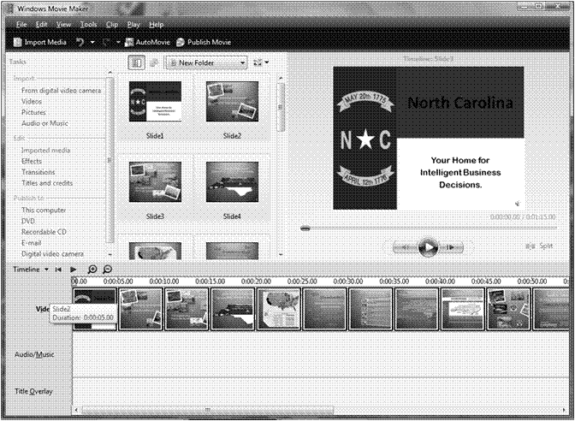

Selecting **Import** places an image of each slide in the **Timeline—Video** bar.

The timing of each slide can be can be lengthened or shortened to match the audio file.

1. Click File, Save the Project As and type the filename, NC-State-Zune-Project.
2. This saves your work as a **Window Movie Maker Project**.
3. The next steps follow a similar process as those you followed to add the audio file.
4. Under the **Import Tasks** selections, click Audio or Music.
5. Navigate to the Window Media Audio file named, **NC-State-Zune-Voice.wma**.
6. Click NC-State-Zune-Voice.wma then click Import.

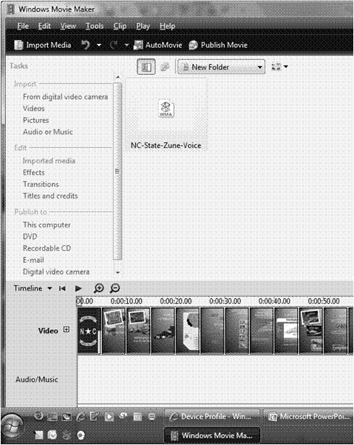

Import deposits the file **NC-State-Zune-Voice.wma** in the Movie Maker file viewing screen.

1. Drag and drop the audio file into the **Audio/Music Timeline**.
2. Because the audio file is longer than the imported images, it stretches past the imported slides.
3. Click File-Save As. Check to see if the filename is **NC-State-Zune-Project**. Type NC-State-Zune-Project if the file name is different.
4. Click Save.

Synchronizing the Audio to the Video

Return to the PowerPoint file titled, **North Carolina_Final_Rec** and make note of the voice narration times. They are located under each slide in the left corner. For example, slide #1 shows the North Carolina flag with a voice narration of 33 seconds. Slide #2 indicates a recording of 23 seconds. Use these timings to begin synchronizing the audio with the images.

Windows Movie Maker

Explore: Using the Slider Bar to Match the Audio Recording to the Images

Record the voice narration timings for each slide in the following table.

|  |  |  |  |  |
| --- | --- | --- | --- | --- |
| **Slide 1** | **Slide 2** | **Slide 3** | **Slide 4** | **Slide 5** |
| **Slide 6** | **Slide 7** | **Slide 8** | **Slide 9** | **Slide 10** |
| **Slide 11** | **Slide 12** | **Slide 13** | **Slide 14** | **Slide 15** |

1. Click Slide 1.  
   When clicking a slide the mouse pointer becomes the hand. This allows you to change the length of time the slide displays on the screen. You want the length of audio to match the length of the slide.
2. Move the hand to the right edge of **Slide 1**. Then the hand becomes a **double red arrow**.
3. **Hold the left mouse button down and move the** arrow to the right.   
   The timing displays as you increase the length of Slide 1.
4. **Stop the slider at 33 seconds**.

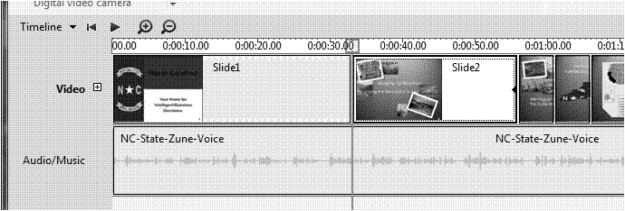

1. Repeat this procedure for the remaining slides. Use the timings you wrote down on the table above.
2. Click File-Save As: **NC-State-Zune-Project**.
3. Move the **Slide Tasker** and click the video start button to periodically review your video. Make adjustments to the length of the images.
4. Remember to Save your progress.

Test Your Knowledge

Practicing synchronizing audio and video using the short PowerPoint and audio you created to practice your skills.

1. Open the PowerPoint file, [*Your Name*]**MyState-Practice.pptx**
2. Make note of how long the recording is for each slide. Write those timings in the table below.

|  |  |  |
| --- | --- | --- |
| 1. Slide 1 | 1. Slide 2 | 1. Slide 3 |

1. Open **Windows Movie Maker.**
2. Click Import Pictures. Navigate to the folder that contains the saved images from the PowerPoint you created. This file should be named: [*Your Name*]**MyState-Practice-images1.**
3. Save the project. Click File—Save As: [*Your Name*]**MyState-Zune-Project.**
4. Click Import Audio. Navigate to the folder that contains the saved audio file from the separate recording you created. This file should be named: [*Your Name*]**MyState-Practice-Voice.**
5. Save the project again.
6. Click Slide #1. Move the hand pointer to the slide handle.
7. Move the Slides to synchronize with the audio recording.
8. Save the file.

Finishing the Video Project

Explore: Publishing the Video in Movie Maker

Windows Movie Maker

1. Open the file **NC-State-Zune-Project.** Or, alternately, open Windows Movie Maker and open the project from the File tab on the toolbar.
2. Under the **Publish To**: category, click This Computer.
3. The file name changes to, **NC-State-Zune-Project_0001.**Note that Vista anticipates that you want the file saved in the Videos folder. You may choose to save in a folder at another location, however.
4. Click Next to accept the filename and saving location.
5. Click the radio button next to **Best quality for playback on my computer (recommended)**The file is saved in Windows Media Video format.   
     
   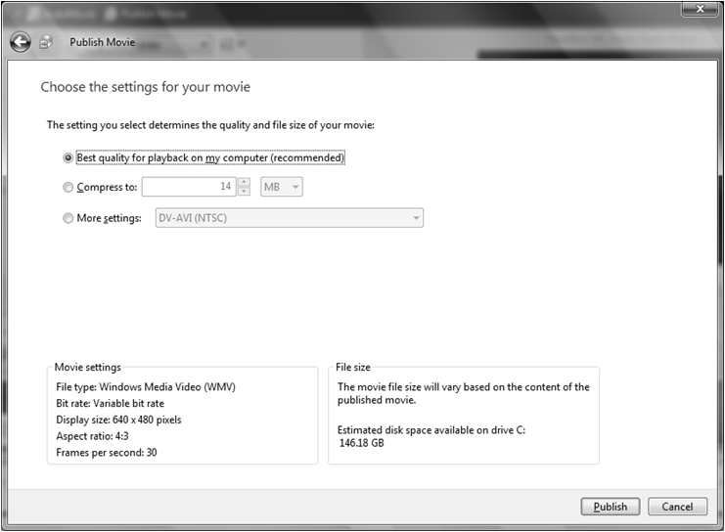
6. Click Publish.
7. It will take a little more than 6 minutes to publish this video. Because you selected to store the video file in the Video folder, Zune automatically reads from that location.
8. Click Finish.

Test Your Knowledge

The tasks below were addressed in this unit. Be sure you understand the terms used and are able to complete the tasks listed. Using the [***Your Name***]**MyState-Zune-Projec**t file, you will publish your video.

1. Open the file, [*Your Name*]MyState-Zune-Project.
2. Click Publish in Windows Movie Maker.
3. Click Next, thereby accepting the filename of [*Your Name*]**MyState-Zune-Project_0001** and the saving location of **Videos**.
4. Click Finish when the video completes the publishing task.
5. View the finished video.

Synchronizing the Video with the Zune Media Player

Explore: Uploading Complete Media Files through Zune Software

1. Click the  Vista button. Type Zune and click Zune to open the Zune application.
2. Log-in to Zune using your Windows Live ID.
3. Connect the Zune Media Player to one of the computer’s USB ports.
4. Wait until the device is recognized and installed.
5. Click Collections and then click Videos.
6. Click the NC-State-Zune-Project and while holding down the left mouse key, drag and drop the video to the Zune icon in the lower left corner.

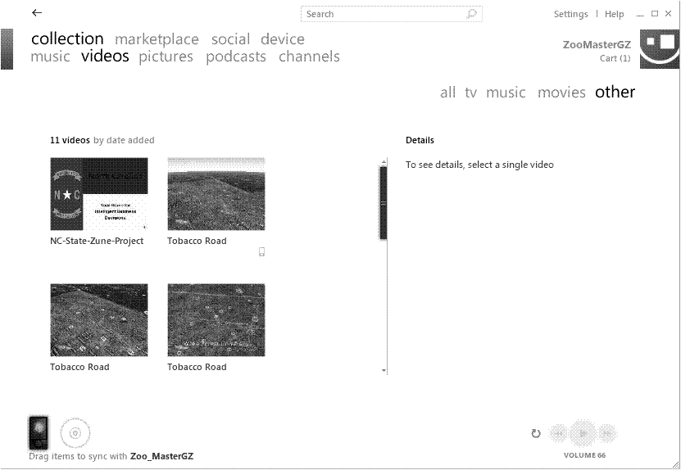

1. When the sync is complete, a small Zune icon will appear in the Zune application indicating that the file is on the device.

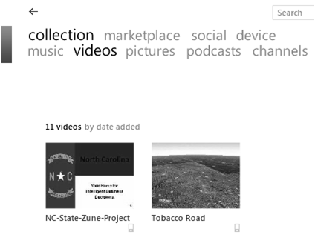

Icon indicates the video has been synced with the device.

1. Connect a set of headphones or connect to an external speaker and show the video.

Test Your Knowledge

Review Me – Syncing Media to the Zune Media Player

1. Open Zune™.
2. Drag and drop your video, [Your Name]MyState-Zune-Project to the Zune icon.
3. Navigate to videos on the Zune, connect the headphones and watch the video.

Curriculum Connections

Students use computers in the classroom as a tool for both productivity and learning. Integrating computer skills with the academic curriculum motivates and engages students, and prepares them for the technology age. Below are a few ideas which can be used to integrate the skills covered in this unit into the academic curriculum.

Idea 1 – Speech Preparation

* Students record an oral presentation for practice.

Idea 2 – Record PowerPoint Presentation

* Review PowerPoint timings and narration.
* Practice rehearsing the presentation content.

Idea 3 – Audio Recording

* Read and record stories.
* Younger students listen to the stories.

Idea 4 -- Podcast

* Use PowerPoint to create study-guides of need-to-know information.
* Flash Cards
* Learn the countries, continents, states
* Learn the Presidents
* Follow the mathematical processes
* Practice arithmetic
* Practice presentations
* Subscribe to podcasts.
* Student created study-guides.
* Download podcasts.

Unit 3: Secretary of State International Business Summit: Creating and Viewing 3-D Media

Unit Objectives

Microsoft Virtual Earth 3-D tour

Microsoft Live Labs Photosynth

Test Your Knowledge

Curriculum Connections

Using Microsoft® Virtual Earth

Each Secretary of State will choose a geographical area to highlight using Microsoft Virtual Earth. The resulting 3-D tour will be saved as a Windows Media Video file and synchronized with the ZuneMedia Player. During the Explore activity, you will create a short 3-D tour showing the locations of four universities along a stretch of Interstate 40.jpg from Winston-Salem, North Carolina to Raleigh, North Carolina. The 3-D video flyover utilizes the newest technology to enhance the viewers’ perspective of the each state’s geography. The steps used in creating the video include:

* Searching for each location;
* Adding a New Collection to Virtual Earth;
* Zooming and rotating the display;
* Placing Pushpins to mark a location;
* Adding photos;
* Saving the collection;
* Creating the 3-D tour.

Explore: Creating a 3-D Tour

Locate and open the class file, ACC_Tobacco_Road_Video.wmv. You will re-create this video.

1. Click the Vista.gif Vista Button and begin typing Virtual Earth to locate the file.
2. Virtual Earth is a web based application and, therefore, utilizes a high-speed Internet connection.
3. In the Live Search box, type Wake Forest University Winston-Salem North Carolina and click the search button.
4. Click the Zoom **+** button to zero in on the University campus.
5. Use Ctrl + Left Mouse button to rotate the display.

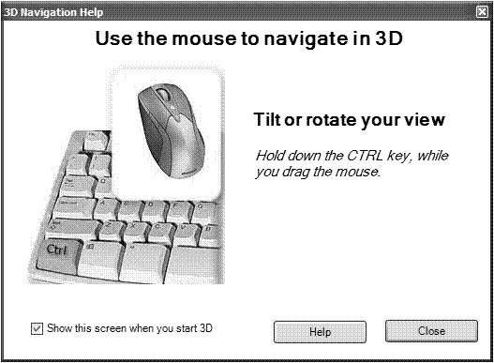

1. Click the Collections Editor in the upper right corner of Virtual Earth. This opens the dialog box from which you will create and save a new collection.

|  |
| --- |
| NewCollection.gif |

1. Click New Collections and type in the Title: box, Tobacco_Road_Flyover . Leave the Sharing boxes checked and click Save .

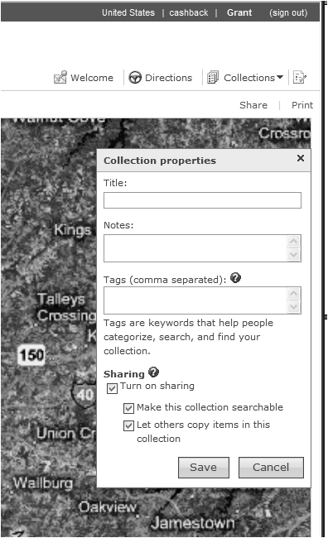

Tobacco_Road_Flyover becomes the filename for the 3-D video.

1. Click the red Pushpin. Position the **Compass** where you want the **Pushpin** anchored.

|  |
| --- |
| WFU.gif  Move the **Compass** to the desired location and click the left mouse button to anchor the Pushpin at that location.  Pushpin |

1. Type Wake Forest University in the **Title box**.   
   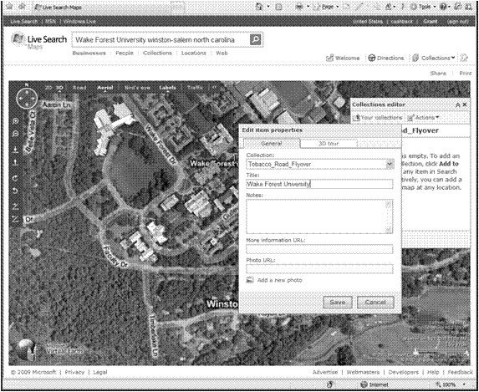

Click Add a New Photo to display and link a picture to the most current Pushpin location.

Add a title to the flyby.

1. Click Add a New Photo. Locate the historical marker photo for Wake Forest University (with permission of NC Office of Archives and History, www.ncmarkers.com), and double-click the .jpg file, WakeMarker.jpg.  
   This uploads the photo to your collection.
2. Click Save .
3. Click to display the Collections Editor dialog box. Click Actions.
4. Click Watch and Create 3-D Video Tour.
5. Click the red Record button.   
   Virtual Earth gives you an opportunity to rename the file if you wish.

|  |
| --- |
| VirtualEarthRecord.gif  Record tour button.  Be sure to check the boxes marked, *Include Photos* and *Show pushpins.*  Click Continue. |

1. After entering the filename (recommended: keep the filename displayed) click Save.
2. You will be greeted with a message that recording a video takes longer than viewing the video. You can work with other files while the video is recording.
3. Open the file, Tabacco_Road_Flyover.wmv to view the video in Windows Media Player.
4. Upload (Sync) the video to the Zune Media Player.

Test your Knowledge

The tasks below were addressed in this unit. Be sure you understand the terms used and are able to complete the tasks listed.

You will finish creating the Tobacco Road video. You will need the following .jpg files (with permission of the NC Office of Archives and History, www.ncmarkers.co):

1. UNCMarker.jpg
2. DukeMarker.jpg
3. NCSUMarker.jpg

Reviewing the activities explored in the previous lesson, visit the remaining three Universities associated with Tobacco Road:

1. University of North Carolina at Chapel Hill
2. Duke University
3. North Carolina State University

Remember these steps for each of the remaining Universities:

1. Type the name of each location in the **Live Search box** and click the search button.
2. Zoom to the University campus center and click the red Pushpin.
3. Navigate the **Compass** back to the center of the campus and click to anchor the Pushpin.
4. Type in the university’s name.
5. Click Add a New Photo.
6. Locate and double-click the photo that matches the university.
7. Click Save.

Microsoft Live Labs Photosynth

Remember when you reached into the box of caramel corn and peanut treat and pulled out the flip book. You marveled at motion animation created by quickly flipping through the pictures that placed the images in slightly different positions. The smiley face grew hair or a beard by the time you reached the last page. Your next step, most likely, emulated the animator’s actions by drawing your own pictures and stapling the pages together to form the flip book.

Microsoft Live Labs took the core idea of creating motion animation from still images to a level unseen before the deployment of Live Labs Photosynth. Using a simple picture taking procedure, i.e., making sure that your pictures overlap by at least 20%, you can create a digital trompe-l'œil, French for “trick the eye,” slide show. The imagery is stunning.

Using Microsoft Live Labs Photosynth, each Secretary of State team creates a Photosynth to emphasize a product strongly associated with the state they represent. The Live Lab team found it necessary to introduce and define a new word to describe what happens in the digital process. *Synthy* is the amount, expressed as a percent, of 3-D nature of a collection of 2-D images. A Photosynth of 67% produces a greater 3-D trompe-l'œil than a synthy of 33%. The more the digital pictures overlap and contain similar lines and colors the greater the synthy of the collection.

Explore: Viewing the North Carolina Product in Photosynth

Microsoft Live Labs Photosynth

In order to view or create a Photosynth, you must download the application to your computer. You will need to sign-in with your Windows Live ID to create a new synth. You do not need to sign-in to view a synth.



When accessing the application from the Internet, you will be asked to sign in with your Windows Live ID.

1. After connecting to the Internet, type the URL, www.photosynth.com in the address box of your browser.
2. The Photosynth home page will be displayed.

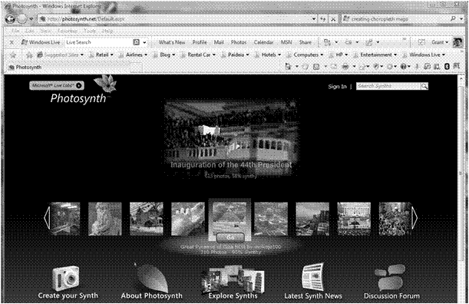

1. In the Search Synths box type, KNS_Pottery and click the Search icon.
2. The synth with the title, KNS_Pottery, zoomaster 4/20/2009, will be displayed.

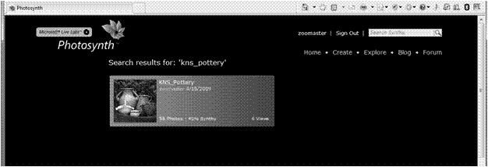

1. Click the picture to activate the synth.
2. Click the directional arrows to move through different 3-D views.
3. Click the slide show start arrow to play the synth as a continuous show.

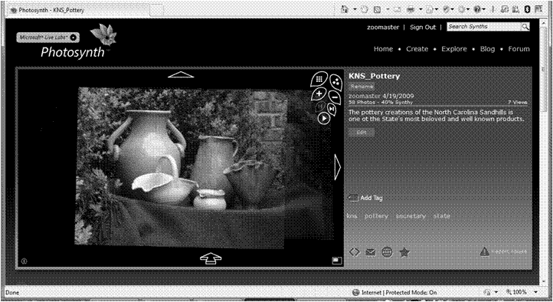

Control Keys

1. North Carolina pottery courtesy of Linda Justice and Grant Zimmerman proprietors of Chatham Gilmore Antiques.
2. Click Home or Explore to view other Synths.

Curriculum Connections

Idea-1 Science

* When studying insects, arthropods, or other animals generally categorized as bugs, create a Synth to accompany a set of diagrams describing the bug’s anatomy.

Idea-2 Mathematics and Design

* In a unit on ratios students design and build a 3-D model of a house. Take pictures of the house and build a Synth to show as part of the presentation.

Idea-3 Literature

* Students use the design of cereal boxes to illustrate and provide information about a book they have read. Create a Synth after taking pictures of all sides of the cereal box.

Use the space below to write down additional curriculum connections ideas:

|  |
| --- |
|  |
|  |
|  |
|  |
|  |
|  |
|  |
|  |
|  |
|  |
|  |
|  |
|  |
|  |
|  |
|  |
|  |
|  |
|  |
|  |

Unit 4: Race to the Planets

Unit Objectives

Create inquiry data questions related to time and distance

Calculate using Microsoft Excel functions

Create a planetary tour using Microsoft Research WorldWide Telescope

Take a Tour of the Solar System with Microsoft Research WorldWide Telescope

Do you enjoy looking up at the stars on a clear night? For thousands of years human kind has tried to refine the science of astronomical studies. Early humans made up stories about the heavens. Much later, using one of the standards of scientific behavior, humans observed that some of the “stars” wandered around the sky in relation to the apparent fixed locations of the stars. The sages of the day called the wanderers, planets. These early astronomers also noticed that the sun seemed to pass through the same group of stars every lunar cycle and, hence every year.

The Zodiac is that group of constellations along the ecliptic plane through which the sun seems to travel as the earth completes its orbit. All the planets orbit near the ecliptic plane. Throughout the year, you will find the planets moving in and out of the zodiacal constellations. Perhaps, when you read about Venus or Jupiter passing through the constellation Scorpius you imagine the deities of Greek and Roman antiquity continue their mythical battles for eternity. Then again, maybe you tend to ignore what happens out our door because the stars are always in the same place every night. Humans like the organization of the heavens because it does not seem to change. The Universe seems organized. After all, everything appears in the sky in the same place year, after year, after year.

How does anyone study something with limited empirical observations? How do we trust the solutions when we do not always understand the mathematics used to answer the question? Maybe, we just censure our study of the Universe because we cannot study it the same way we can study science with plants and animals.

In the learning plan, “Race to the Planets,” students ask questions that help them understand the enormity of our Solar System and our Universe. The essential question, “How long would it take to run to each of the planets?” provides the foundation for inquiry that elevates each student’s science literacy. To understand the great dimensions of space, collaborative teams of students set up a scaled Solar System racecourse. This learning activity does not work with the curvature of space. It uses plane geometry in the design of a straight-line racecourse.

Your observations include time and distance data that come from telescopes not microscopes. Students will work with times and distances they already understand as they try to think “between the lines” to articulate a greater understanding of the distances in space. So in a way, they are thinking like the ancient astronomers trying to put time and distance in perspective while using the interactive, Microsoft Research WorldWide Telescope.

Integration Project Learning Plan

| KNS  For Standards-based, Student-centered, Technology-rich Learning | Teacher: | Grant Zimmerman |
| --- | --- | --- |
| School/District: | Chapel Hill-Carrboro City Schools |
| Subject Area(s) Addressed: | Science, Physical Education, Math, History, Art, Technology |
| Grade Level(s)/Course: | 5-12 |
| Date Submitted: | June 2009 |
| Lesson Duration: | 1-2 weeks (50 minute classes) |

|  |  |  |
| --- | --- | --- |
| Unit Title | The Dimensions of Time | |
| Lesson Title | Race to the Planets | |
| General Lesson  Outcomes | The students use the knowledge they have learned about time, measurement, distance, scientists, art, and technology to build a greater understanding of the Solar System. | |
| **Academic Standards Addressed (List source & #)** | The learner will build understanding of the Solar System.  Compare and contrast the Earth to other planets in terms of size, composition, relative distance from the sun, and the ability to support life.  Recognize and analyze the connections between the planet’s names and their mythological namesakes.  Use and analyze the relationship between time, distance, and speed.  The learner will build an understanding of statistical principles.  Apply the formulas of mean, median, and range.  The learner will apply the principles of healthful living through exercise.  Running  The learner will use authentic, real world data.  Create a multimedia presentation using Microsoft® World Wide Telescope™.  Include titles, distance data, time data, and images relating to the planets’ names. | |
| **Technology Standards Addressed (List source & #)** | The learner will demonstrate knowledge and skills in the use of computer and other technologies.  Use spreadsheet terms, concepts, and functions to calculate, represent, and explain content area findings.  The learner will use a variety of technologies to access, analyze, interpret, synthesize, apply, and communicate information.  Plan and develop database reports to organize, explain, and display findings in content areas as a collaborative group.  Modify or create spreadsheets to calculate and graph data to incorporate into content area projects (e.g., word processing, multimedia, Microsoft® World Wide Telescope™).  Modify or create spreadsheets to solve problems, make decisions, support, and display findings in content areas projects. | |
| **Teacher-Led Activities (Introductory Lesson)** | The teacher will:  Pair students to collaborate with each other.  Present the tools used to collect the time it takes to run to each planet on a scaled representation of the Solar System.  Schedule a time and location to layout the scaled Solar System racecourse in an  outdoor space extending to 250 feet, or, alternately,  Create an indoor location in which the racers would run a set distance multiple times.  Teach and coach the workings of Microsoft World Wide Telescope.  Teach and coach the use of spreadsheet formulas.  Teach and coach the creation of charts derived from collected data.  Present a suggested learning assessment rubric and coach students as they design an assessment rubric for their collaborative group. | |
| **Student-Centered  Activities** | Students use a spreadsheet to build a table showing each planet’s scaled distance from the sun.  Students layout the scaled racecourse.  Students race to each planet and collect the time it takes to reach each planet.  Students collect each planet’s perihelion and aphelion.  Students return to the original spreadsheet to analyze the researched data and the collected data.  Students create a tour of the planets showing the relationship of the actual distance data and the scaled distance data.  Students include in the tour images of historical art that represents each planet’s name.  Students present their tour as a part of the larger unit of study. | |
| **Resources Needed** | Content resources (books, articles, speakers, handouts, materials, etc.) | Software/Web Resources (CD-ROMs,URLs, etc.) |
| Diagram of the Solar System  Large open outdoor space (250 feet)  Indoor space  Planet signs | Microsoft Office 2007  Microsoft Research WorldWide Telescope  Internet connection  <http://www.worldwidetelescope.org/Home.aspx> |
| Hardware (computers, TV, DVD, etc.) | Other media, video, satellite, etc. |
| One computer for every two students  Internet connection |  |
| **Student Assessment Strategy** | Student and teacher designed rubric. | |

Collecting, Analyzing, and Presenting Planet Data

Each collaborative team will collect distance data for each planet in the Solar System. For the purposes of this class, the time taken to run to each scaled planet distance is based on running a seven-minute mile. The scaled distance to Neptune is arbitrary. Most baseball or football fields encompass at least 300 feet. Use the simple ratio to find the scaled distance of each planet.

$$\frac{Earth^{'}s Distance}{Neptune^{'}s Distance}=\frac{x}{250ft}$$

This ratio gives you the distance to locate each planet outside of school or inside the school field. Each team creates a table constructed of the scaled distances and lays out the planet racecourse in the chosen location.

You use a similar ratio to find the estimated time to run to each planet.

$$\frac{Running Distance}{5280 feet}=\frac{x}{420 seconds}$$

Planet Data Collection

Explore: Collecting the Data and Completing the Calculations

Using Microsoft Research WorldWide Telescope as the one-stop research tool, write in the table each planet’s aphelion and perihelion.

|  |  |  |
| --- | --- | --- |
|  | Aphelion | Perihelion |
| Mercury | 69,816,900 km | 46,001,200 km |
| Venus |  |  |
| earth |  |  |
| Mars |  |  |
| Jupiter |  |  |
| Saturn |  |  |
| Neptune |  |  |
| Uranus |  |  |

1. Click the Vista.gif Vista Button and begin typing WorldWide Telescope to locate the file.
2. Microsoft Research WorldWide Telescope (WWT) is a web based application and therefore, utilizes a high-speed Internet connection.
3. After reading the initial instructions for WWT, click Close.
4. Click the Solar System view in the bottom left **Look At** selection box.

|  |
| --- |
| WWTLookAT.gif |

1. Click the Sun image to locate the Solar System.
2. Next, click Mercury to travel to the planet.
3. Right click Mercury to display the **Information** dialog box.
4. Click Information and then select Look up on Wikipedia.
5. WWT provides not only 3-D view of the Universe, but a one-stop location for collecting research.
6. Compare and confirm Mercury’s distance from the Sun to the data in the table at the start of this Explore Activity.
7. Click the each planet in succession to collect and write the distance data in the table.
8. Locate and open the Excel file Planet-Distance-Initial-Data.xlsx.
9. Enter the collected distance data from the table into the spreadsheet.
10. Click the Obutton.gifOffice Button and select Save As. Enter Planet-Distance-Data.xlsx as the new file name.

Explore: Using the AVERAGE Function.

1. Open the file Planet-Distance-Data.xlsx.
2. Move to Cell D10. Click the Insert Function button FxKey.gif.
3. This places an **equal sig**n in Cell D9 and opens the **Insert Function dialog box**.

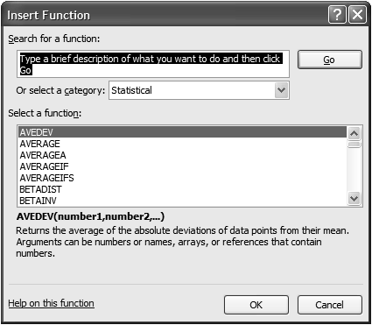

The Insert Function provides assistance in selecting the correct formula. Spreadsheet formulas differ in appearance compared with linear equations.

The formula =AVERAGE(B9:C9) calculates the mean beginning with Cell B9 and continuing through C9.

1. Click **AVERAGE** and then click **OK**.
2. Confirm the Cell range being averaged in the **Function Argument** dialog box. Click **OK** if the Cell range referenced is correct.
3. This places the Function, =AVERAGE(B9:C9) in Cell D10 and displays the average of Mercury’s aphelion and perihelion as **57,909,050 km**.
4. Use the Copy Handle to replicate the formula down the column for each planet listed.
5. Click the Save icon or Click the Obutton.gifOffice Button and select **Save As**. Change the file name if you desire.
6. Explore: Copying Distance and Running Time Data
7. You will complete the data calculation by copying the existing formulas.
8. If the Excel file you are currently working with is not open, then find and open **Planet-Distance-Data.xlsx**.
9. A completed file containing all of the calculations is included in your set of Class Files under the file name **Race-to-the-Planets-Complete.xlsx**.
10. Move to Cell E9. Click and Hold the left mouse button down while moving the mouse pointer to Cell I9.
11. This highlights the Cell range E9:I9.
12. The **Copy Handle** is now located in the bottom right corner of Cell I9. Move the mouse pointer until the **Copy Handle** becomes a cross.

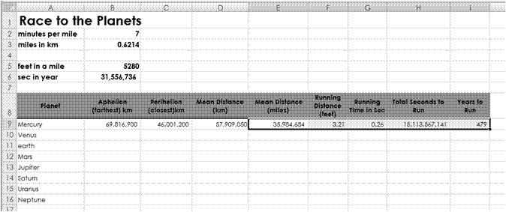

1. Grab the **Cross** while holding down the left mouse button and drag the **Cross** to Cell I16. Release the left mouse button to copy the formulas.

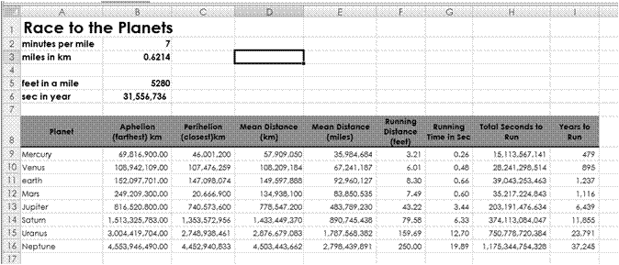

Copied Cells.

1. Save the file.

Creating Race to the Planets Presentation

You will use Microsoft Research WorldWide Telescope to create an animated slide show of the Solar System’s eight planets.

Explore: Putting the Slide Show Together

1. Make sure Microsoft Research WorldWide Telescope is open.
2. Click Look at - Solar System.
3. Click the arrow on the bottom of the **Guided Tours button**.
4. Click Create New Tour.
5. The **Tour Properties** dialog box opens.

Race to the Planets

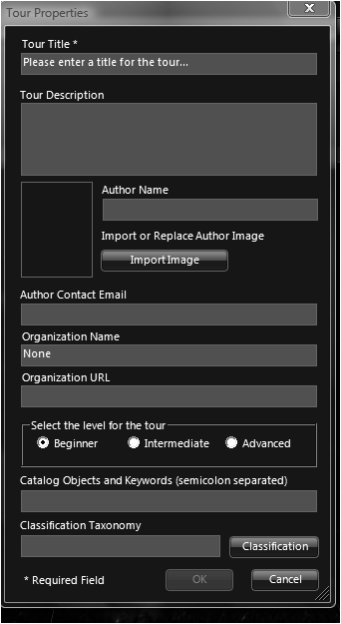

Complete the remaining information blocks.

A tour of the Solar System showing each planet’s namesake and data that answer the questions “How big is the Solar System?” and “How long would it take to run to each planet?”

1. Click OK.
2. Looking at the Solar System view, click the “+ sign” until you reach the desired zoom level of the Sun.
3. Click the first Add a Slide box.
4. The image of the Solar System and Sun will appear in the first Add a Slide box.
5. Click the Text box and type the title Race to the Planets. Click Save.
6. You will be able to move and resize the title by clicking and dragging the text box handles.
7. Click the planet slide Mercury on the bottom filmstrip.
8. Click the second position Add a Slide to place Mercury on the next slide.
9. Click the Text box to add information.
10. Type Mercury , click Enter. Type 35,984,684 miles from the Sun, click Enter. Type 479 years to run to Mercury, click Enter. Click Save.
11. Click the On Slide Text box , grab the move handle and move the text toward the upper left corner.
12. Click the Picture box. Locate the .jpg image **MercuriusArtusQuelinus.jpg** and click **Open** to place the picture on the Mercury slide.

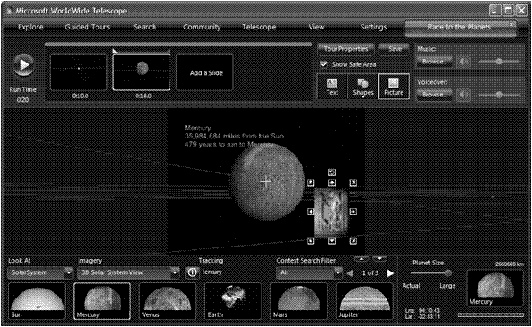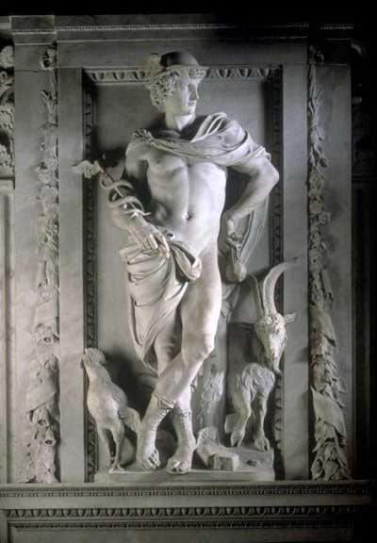

1. Click Venus. Click the minus sign or the plus sign to decrease or increase the zoom level.
2. Click the third position Add a Slide to place Venus in the third location.
3. Click the Text box and type Venus, click Enter. Type 67,241,187 miles from the Sun, click Enter. Type 895 years to run to Venus, click Enter. Click Save.
4. Click Picture. Locate **Venus.jpg**. Click the file name. Click Open to insert the image into the Venus slide.
5. Grab the move handle to reposition the image in the lower right corner. Resize the image as needed.
6. Click the arrow at the bottom of the Guided Tour button. Click Save Tour As. Type the Race-2-the-Planets to name the file.

|  |
| --- |
| VenusWWT.gif |

Test Your Knowledge

The tasks below were addressed in this unit. Be sure you understand the terms used and are able to complete the tasks listed.

Compete the Microsoft® Research WorldWide Telescope Race to the Planets slide show.

1. Follow the procedures you learned in the **Explore** activity and complete the slide show.
2. Be sure to **Save** your tour.
3. Click the playback Start arrow to preview your tour.

|  |
| --- |
| WWTStart.gif |

1. Click on the **seconds under each slide** to increase or decrease the time each slide appears on the screen.

Curriculum Connections

Students use computers in the classroom as a tool for both productivity and learning. Integrating computer skills with the academic curriculum motivates and engages students, and prepares them for the technology age.

Below are a few ideas which can be used to integrate the skills covered in this unit into the academic curriculum.

Idea 1 – Tour the Galaxies

* Categorize galaxies by their shape.

Idea 2 – Determine each planet’s gravitational field

* Collect and analyze data on the planets’ gravity.
* Ask, “How much does an object with the same mass weigh on different planets?”

Idea 3 – Name the major stars in name constellations

* Click Collections-Constellations
* Aim the Finder Scope to each star.
* Record the magnitude and distance from earth data

Use the space below to write down additional curriculum connections ideas:

|  |
| --- |
|  |
|  |
|  |
|  |
|  |
|  |
|  |
|  |
|  |
|  |
|  |
|  |
|  |
|  |
|  |
|  |
|  |
|  |
|  |
|  |

Unit 5: Another 21st Century Tool to Manage Your Work

Unit Objectives

Create Live Mesh Folders

Another 21st Century Tool to Aid Collaboration

So, you consider yourself to be a 21st century teacher or learner! How many times have you or your students **forgotten to e-mail a document** or put it on the flash drive, leaving for work or school and realizing—too late—that it is not available when you need it? An “**anytime, anywhere learning attitude**” requires use of multiple types of hardware—PCs, tablet PCs, smart phones, etc., and a means to **synchronize work** between them.

Microsoft has tools available to allow learners to collaborate on projects from several locations, not just using the school network. You have already experienced the usefulness of MS Office Live to share documents and document versions. Now you will look at a few tools that enable you to collaborate across locations, access multiple media files and documents, and provide controlled access to others more efficiently.

MS Live Mesh

MS Live Mesh **connects you, seamlessly**, to the people, devices, programs, and information that you care about—wherever you happen to be. **YOU create your mesh**, adding devices, specifying what information is available and to whom, and synchronizing your network so that the most up-to-date versions are available at all times.

The best feature of Live Mesh is that you can **connect to your remote computer** and then use it as if you were sitting right in front of it! Once you access, edit, or do whatever work is required on the remote computer, you can copy and paste files between your local computer and your remote computer as necessary. MS Live Mesh puts YOU at the center of your digital world!

Setting Up a Live Mesh Network

Setting up a Live Mesh network is easy! You will use the same Windows Live ID you have created as your single sign-on.

1. Go to the website <https://www.mesh.com/Welcome/default.aspx>. A welcome page will appear.
2. Click Sign In, read the agreement on the following page, and then click I agree. The next page shows hypothetical devices that you could add to your mesh, as well as the Live Mesh Live Desktop that is always accessible. Go to the right side of the mesh and click the large orange plus sign. The mesh rotates so that the plus sign is in the center.
3. Select your system in the For: box and click Install. Select Run in each of the next two dialog boxes that appear.
4. Follow instructions for installation of software if it is not currently installed on your machine and for signing in. Ask your instructor for assistance, if necessary.
5. Live Mesh should be installed on your machine and you should now be ready to set up folders for sharing.

Explore: Navigating the Live Mesh Website

When you are logged in to Live Mesh, you can choose to view three different windows:

* Desktop. The Desktop is very similar to the desktop on your laptop or PC in that it shows files and folders available for your easy access. Click Desktop in the taskbar at the top of the screen. There should be only one folder on your desktop, one titled *Create new folder*.
* Devices. This screen shows all the machines that have been added to your mesh. You can connect with any of these. Currently, your devices should include the Live Desktop and the machine on which you are presently working. Click Devices to see what machines are included on your mesh.
* News. The news screen provides you with a list of recent activity to the Live Mesh site.

1. Click News. The creation of your mesh should be listed.
2. Leave Live Mesh open for the next activity.
3. 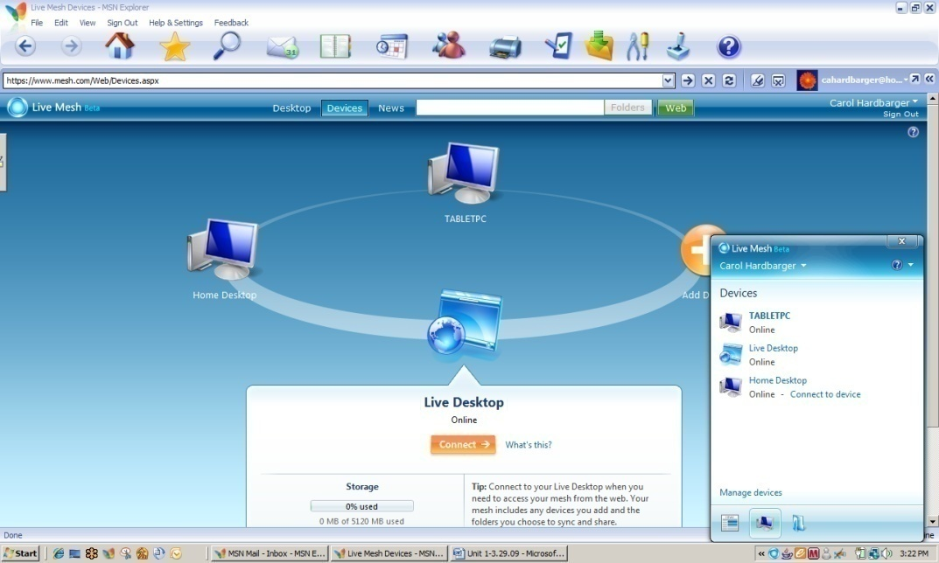The Devices screen should appear similar to the one below. Note the smaller navigation pane in the lower right corner, which appears if you click the Live Mesh icon in the lower right task bar.

*Live Mesh Devices Screen*

Creating a Folder for Your Project Work

If you know you will be using multiple computers for various assignments, installing and using Live Mesh ensures that your work will always be available. The advantage of using Live Mesh over a storage site such as Office Live is that you can access the most recent document or version available. For example, a document that was revised at home and stored on the home computer can be accessed by using Live Mesh, even if it was not placed in the Live Mesh desktop folders.

1. If necessary, open and sign in to Live Mesh. Click Desktop to access the Desktop screen.
2. Double click Create new folder to open the New Folder dialog box. In the Name: box, type [Your Name] Secretary of State.
3. Click Show synchronization options. Make certain that When files are modified or added is selected for each device. Click OK. The folder now appears on your Live Desktop.
4. Double click to open the folder. A folder navigation pane and a news pane will appear that are similar to the ones below.
5. Leave Live Mesh and the navigation pane open for the next activity.

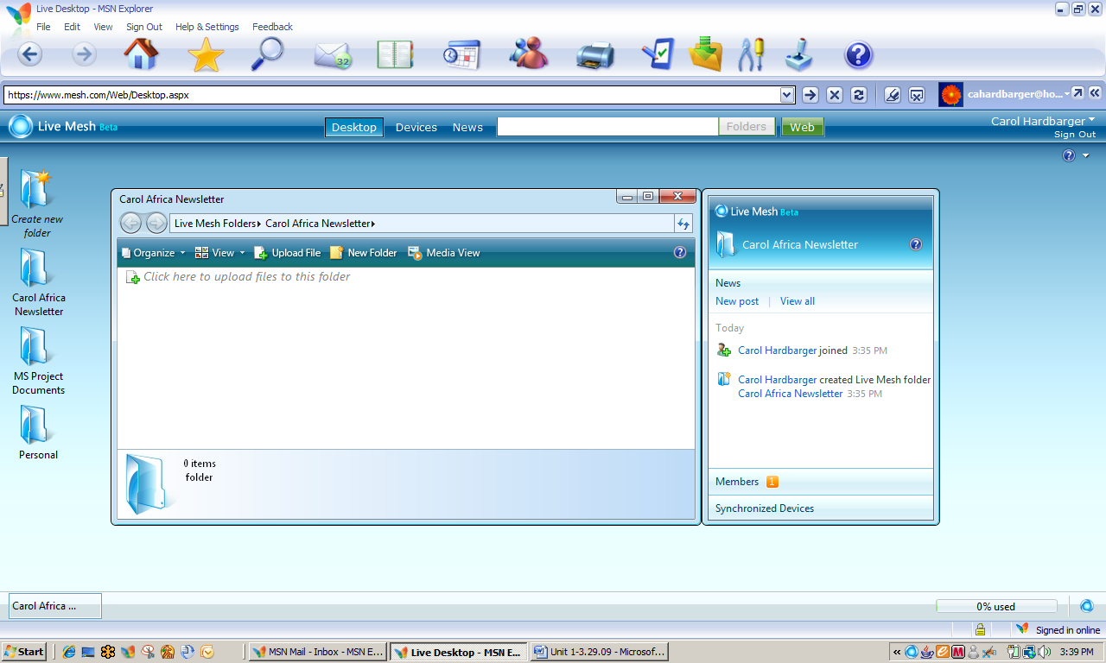

Live Mesh Folder Navigation Pane

Uploading Files to a Live Mesh Desktop Folder

Once you have created desktop folders on Live Mesh, it is easy to upload files.

1. If necessary, open Live Mesh and [Your] Secretary of State folder. In the folder navigation pane, click Click here to upload files to this folder.
2. Select the Excel file, State_Data.xlsx and then click Open. The spreadsheet file has now been added to your Live Mesh desktop.
3. Leave both the folder navigation pane and Live Mesh open for the next activity.

Sharing Live Mesh Desktops and Folders

You can provide access to any of your desktop folders to any individual or group of individuals you wish, but, just as with Office Live, you must invite them.

1. If necessary, open Live Mesh and the Secretary of State project folder. In the news pane, click Members and then Invite. The **Invite Members** dialog box will appear.
2. Invite your partner from Unit 1 and one additional person from this class, typing their e-mail addresses – separated by a semicolon – in the **Members:** box. In the **Permissions:** box, select Contributor. Click OK.
3. Close the folder navigation pane and leave Live Mesh Open.
4. **Note**: To access a remote desktop, the Sleep or Hibernation feature of the remote device **must be disabled**.

Explore: Accessing a Shared File on a Remote Desktop

“But, Mr. Z, I did my homework, but I left it on my computer at home!” Have you ever heard that excuse? In this activity, you will access your partner’s desktop to open a document to review, edit, and then to save.

1. If necessary, log on to Live Mesh. Make certain that the file, [Your Name] MyState-Practice.pptx, has been added to your Live Mesh project folder on your desktop.
2. You should have received an e-mail from your partner inviting you to share a folder with Live Mesh. Open that e-mail.
3. Click Click here to view the invitation, which will take you to the following screen.
4. 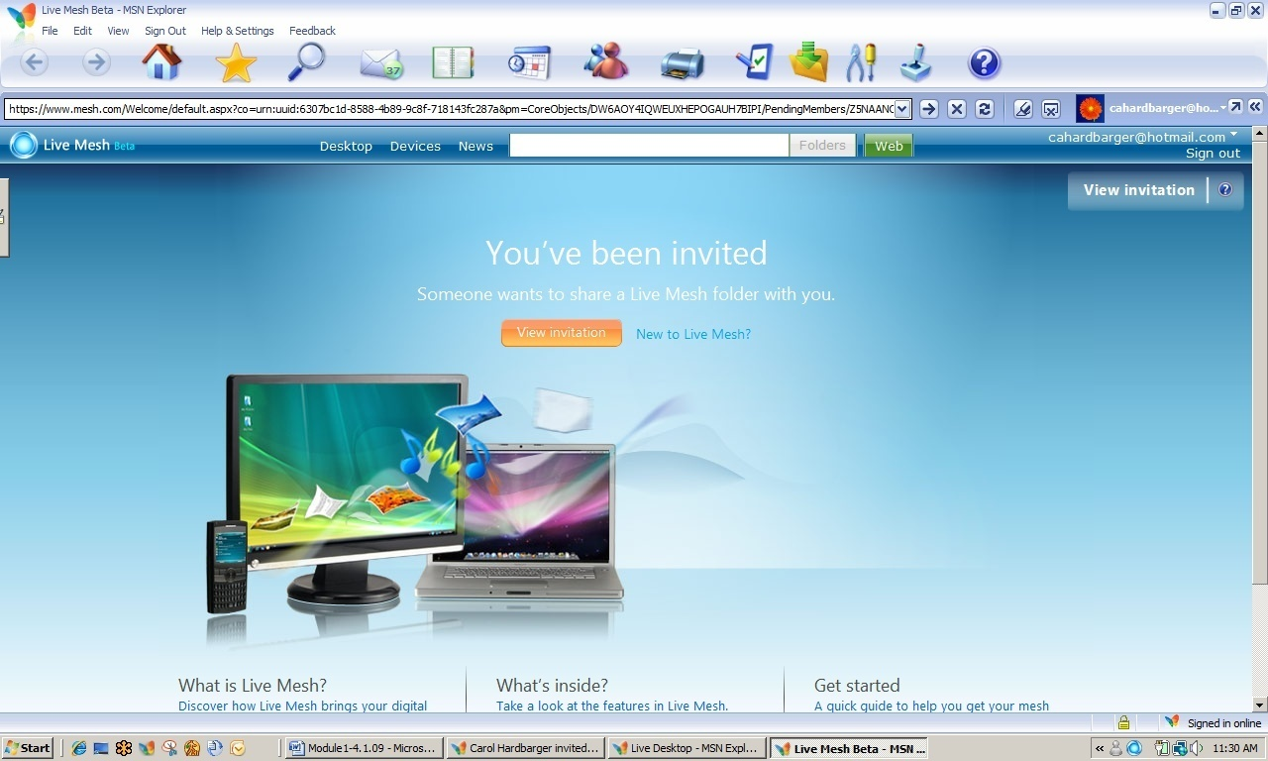At the next screen, click Accept Invitation. You will be directed immediately to the desktop location of your partner’s shared file. **Note**: You are actually accessing a file stored on a desktop, not on a website.
5. Double click the file to open or save it. Select Save this file now and then click OK. Keep the same name and save the file to your student files.
6. Close any open files and close Live Mesh.

Test Your Knowledge

The tasks below were addressed in this unit. Be sure you understand the terms used and are able to complete the tasks listed.

Review Me – Using Live Mesh

1. Open Live Mesh and create a desktop folder to store your Race to the Planets research. Add the Excel file to the folder.

Curriculum Connections

Students use computers in the classroom as a tool for both productivity and learning. Integrating computer skills with the academic curriculum motivates and engages students, and prepares them for the technology age. Below are a few ideas which can be used to integrate the skills covered in this unit into the academic curriculum.

Idea 1– Creating a Paperless Environment

* The 6th grade science teacher at Homestead Middle School works one-half day in two different locations. He has created a mesh that includes the desktop computers in each of his two work locations, his home desktop, and his laptop. There is never an inconvenience caused by last-minute interruptions or other circumstances that prevent e-mailing documents, downloading them to a flash drive, or printing out hard copies.

Use the space below to write down additional curriculum connections ideas:

|  |
| --- |
|  |
|  |
|  |
|  |
|  |
|  |
|  |
|  |
|  |
|  |
|  |
|  |
|  |
|  |
|  |
|  |
|  |
|  |
|  |
|  |

Unit 6: Project Review

Project Objectives

Secretary of State Planning Grid

Project-based Learning

Secretary of State Planning Grid

|  |  |  |  |
| --- | --- | --- | --- |
| Maps | Lists | Pictures and Text | Other |
| **Political Map:**  Shaded area **U.S.** **Population** map using 7 colors  Graph state’s population from 1900 to 2000. | State’s Population  Capital’s Population | **Famous People**  Find a minimum of 3 people. Find or create a picture and caption using 5 W’s. | Presentation Skills  Create Conference Survey |
| **Political Map:**  Shaded **U.S. Population Density** map using 7 colors | Date Admitted to the Union  Date Southern State seceded from the Union | **Historical Firsts**  Find a minimum of 3 historical firsts. Create picture and identify with a  5 W’s caption. | Create Student Planning Calendar. |
| **Physical Map:**  Shaded area **U.S. Square Miles** map using 7 colors | 5 Largest Cities and their population | **Presidents:**  Term of Office  Political Party  3 Big Events  Family Size | **Time Line**  Historical firsts, famous people using pictures and text |
| **Political State map** showing:  Capital  5 Largest Cities  Indian Reservations  Major Transportation  Colleges and Universities | **Population Rank**  Identify by ordinal ranking; include the #1 state, #50 state, and selected state’s rank | Create and label 5 examples of State recognized flora and fauna. | Take pictures of one of the  State’s main product and create a Photosynth. |
| **Economic Features**  Use a State Map to illustrate:  agriculture products  manufacturing  mining products | Student Choice | State Flag and State Motto (Word Art) | Create and Review Rubric |
| **Historical State Map** Create captions for a minimum of 3 state historical landmarks | Student Choice | Use Microsoft Virtual Earth to create a short 3-D tour of an important state attribute. | **Bibliography**  Use a minimum of three different sources: e.g., encyclopedia, internet, book on the state |
| **Physical State Map**  Create a state map showing mountains, rivers, lakes, deserts, the 5 largest cities, etc. | Square Miles and Rank  include #1, #50, and state’s rank in area | 10-15 slide Power Point  Save as PowerPoint and as JPEG. Create voice over.  Upload to Zune. | Keep files on Windows Live Space and Windows Live Mesh. |

Putting it All Together

As an educator, you increasingly work with students of diverse backgrounds, cultures, native languages, and ability levels. Project based learning is one way to provide a greater range of learning opportunities to your classroom. Working on a project with others motivates learners by allowing them to work with content in the context of real-world situations (Katz & Chard, 1989). Additionally, twenty years of research has shown that motivation has a positive impact on achievement (Brewster & Fager, 2000).

Particular benefits of project based learning include the following:

* Preparing children for the workplace;
* Increasing motivation;
* Connecting learning at school with realit;.
* Providing collaborative opportunities to construct knowledge;
* Increasing social and communication skills;
* Increasing problem solving skills;
* Enabling students to make and see connections between disciplines;
* Providing opportunities for children to contribute to their school or community;
* Increasing self-esteem;
* Allowing children to use their individual learning strengths and diverse approaches to learning;
* Providing a practical, real world way to learn technology. (Northwest Regional Educational Library, 2002)

Possibilities for projects are endless—the key for successful project implementation is that it be challenging, student-driven, and meaningful.

Explore: Thinking about the Benefits of Project Based Learning

Think about the multi-disciplinary Secretary of State Project with which you worked and ways that it would benefit educators and students.

Using the information above, list at least three ways that the Secretary of State or the Race to the Planets project would benefit students. An example has been provided.

|  |  |
| --- | --- |
| **Benefit** | **How It Benefits** |
| Students present their work to an audience. | Students are highly motivated to do better than their best when they know their work is for a vested audience. |
|  |  |
|  |  |
|  |  |
|  |  |

MS Tools to Aid Project Based Learning

You have explored a variety of MS Office and other Microsoft tools that can greatly enhance students’ experiences with project based learning.

Explore: Selecting the Right Tool for the Job

Following is a list of Microsoft tools used with the Secretary of State Project and the Race to the Planets. Project activities you completed were within the framework of student assignments, but only reflected one or a few potential uses of the applications involved.

For each of the listed PC- or web-based applications, identify at least one additional use by teachers or students for completion of a project.

* MS Office Excel 2007 -
* MS Vista -
* MS Office Word 2007 -
* MS Office PowerPoint 2007 -
* Live Mesh –
* MS Virtual Earth -
* MS World-wide Telescope -
* Zune –
* Movie Maker -
* Sound Recorder -

Designing a Project Based Unit

As you have seen, project based learning can be used with student teams in a single classroom, across several classrooms in the same content area, or in multidisciplinary classroom settings. Planning is an extremely important aspect of facilitating successful projects:

1. Outline project goals.
2. Identify learning goals and objectives.
3. Plan activities. Make sure the project is student-entered, challenging, and relevant/meaningful.

The following is a list of ideas for projects that could be implemented in a single or multiple-disciplinary setting.

* Design a natural history museum featuring local flora and fauna.
* Design and plan a school or community garden focused on balanced nutrition.
  + Design a brochure or Website on local gardening facts.
* Develop a newsletter or Website on recycling, energy conversation, or other area of interest to the community.
* Create a book on tape for a senior center or elementary school class.
* Create a wildlife or botanical guide for a local wildlife area.
  + Develop a wildlife habitat.
* Develop a business using locally available raw materials.
* Create an exhibit in a local museum or community center, produce audiotapes, videotapes, and books with photographs. Produce a Web site as a "virtual tour" of the history.

A Garden Focused on Balanced Nutrition

A garden project would be a perfect one for collaboration across disciplines; however, it would work well in a single classroom if the teacher provided non-content specific information, templates, and other resources. The teacher can also control the breadth of the project by focusing on several content-specific goals and objectives. The following example shows how Mary Rose, a 5th grade science teacher, develops a school garden project within the context of the curriculum she is currently presenting.

Garden Project (grades 3-12)

1. Project Goals and Outcomes
   1. Accurate information about ideal gardening conditions in our area for spring planting and summer.
   2. Practical use of food pyramid to correlate with cool and warm weather crops.
   3. Outline of subsequent plantings of warm weather crops.
   4. Poster of food pyramid as a collage of vegetables to be grown accompanied by written justification of choices.
   5. Interact with community.
2. Learning Goals and Objectives
   1. Students understand the importance of identifying accurate information about gardening conditions for a locality and the relationship of that information to choice of crops.
      1. Use Internet and print resources to determine USDA Hardiness Zone of local area.
      2. Identify crops—type and variety--that grow well in local area.
   2. Students understand the relationship of local gardening conditions to the *when and how to plant* information about individual crops.
      1. Use Internet and print resources to divide crops into cool weather and warm weather crops.
      2. List basic planting instructions for each crop.
   3. Students understand the relationship between crop selection and nutritional needs.
      1. Classify crops compatible with local area into food pyramid categories.
      2. Select 4 cool weather crops and 5 warm weather crops that would provide the most nutrition based on the food pyramid.
      3. Create poster of two food pyramids with clip art or magazine pictures of vegetables chosen.
         1. Create a food pyramid using cool weather vegetables.
         2. Create a good pyramid using warm weather vegetables.
         3. Display posters in local garden center(s) and grocery stores.

Explore: Designing a Multi-disciplinary Project

After Mrs. Rose implemented the 5th grade school garden project, several of her peers decided they would be interested in having their students work on the same project. Using the process discussed in this course, they identified multidisciplinary goals, content-specific goals, objectives, and assessments, and multidisciplinary assessment tools.

Project design is flexible enough that most project themes can fit in with whatever content is being addressed at the time. For example, Mrs. Rose’s class could have worked on a garden project focused on soil types. The same is true of a multidisciplinary project—collaborating teachers determine the outcomes and appropriate multidisciplinary and content goals and objectives based on where they are in the individual curriculum.

1. In the space below, brainstorm with a partner to add possible content that would fit in the grade levels at your school as a multidisciplinary project. A few things have been filled in to get you started.
2. List how the following Microsoft tools might be used in the project.

* MS Excel:
* MS Word:
* MS PowerPoint:
* Zune
* Movie Maker
* Sound Recorder
* Virtual Earth
* Live Mesh:

**Science**

Plant structure

**Math**

Percent germination

**Language Arts**

Written plant descriptions

**Art**

Paper Mache plants

**Agriculture**

Soils

**Health/PE**

Nutrition

**Industrial Arts**

Build raised garden bed

**Social Studies**

Heirloom plants

Explore: Changing Classroom Practice

1. Working with a partner, brainstorm to respond the following questions.
2. What project or activity do I now do that can be changed to incorporate project based learning?
3. How can I make activities in my classroom more collaborative?
4. How can I collaborate more with teachers in other disciplines?
5. How can I use technologies to aid collaborations with teachers in other disciplines?

Next Steps

In order for technology integration to truly enhance teaching and learning in your classroom, the process of learning to integrate technology into your curriculum cannot end today. It is important for you to reviewwhat you have learned in today’s session, to discuss your ideas with your colleagues, and to make a conscious effort to include technology in your learning plans ubiquitously.

Technology is not a discrete content area, but a dynamic, knowledge-building set of tools that can play an important role in all levels and subjects for every learner. As you take more courses on the effective use of technology as it relates to your curriculum, you will be able to extend and synthesize your knowledge and experiences into specific plans for engaging activities. With standards-based, student-centered, technology-rich learning, no student will be left behind!

Appendix : Resources

Objectives

Gaining Additional Knowledge Regarding Project-based Learning

Resources for Project Based Learning and Collaboration

Select Online Resources for Project Based Learning

1. The Center for Innovation in Engineering and Science Education (CIESE) has a website with multiple projects that involve collaboration with classrooms across the country and globe. The curricular emphases of the projects could be expanded at the local level to include mathematics and social studies. Also, availability of multiple projects and ongoing data collection activities enables integration over a time span.

<http://www.k12science.org/collabprojs.html>

Sample projects include the areas of human genetics, water quality, monitoring the sun, daily water use, and human impact on the oceans.

The Center also has project ideas for collection of “real time data” in climatology.

<http://www.k12science.org/realtimeproj.html>

1. The US Census Bureau provides teaching resources and data; older students can access Census datasets.

<http://www.census.gov/dmd/www/teachers.html>

1. The Math Library of the Drexel School of Education publishes a website with numerous collaborative and other projects. The projects have online data entry and access to data from other participating schools. Non-collaborative, classroom projects are also available.

<http://mathforum.org/workshops/sum96/data.collections/datalibrary/>

1. The Energy Information Administration publishes weekly updates of retail gas prices by nation, region, and state.

<http://www.eia.doe.gov/oil_gas/petroleum/data_publications/wrgp/mogas_home_page.html>

1. Annenberg Media has a global wildlife migration tracking project that can be used year-round.

<http://www.learner.org/jnorth/Sitemap.html>

1. The Blue Web'N: A Library of Blue Ribbon Learning Sites on the Web   
   <http://www.kn.pacbell.com/wired/bluewebn/>
2. **Education World: Collaborative Projects K-12**  
   <http://www.education-world.com/projects/index.shtml>
3. **Global School House Internet Project Registry**  
   <http://www.globalschoolhouse.org/pr/>
4. **Handbook of Engaged Learning Projects**<http://www-ed.fnal.gov/help/index.html>
5. **Starting in the Middle 2000: Integrated Project Designs for Idaho Middle Level Students, Volume II**<http://www.nwrel.org/ecc/middle_2000/>
6. NC Office of Archives and History, the Department of Cultural Resources

<http://www.ncmarkers.com>

Modeled after a program begun in Virginia, the North Carolina legislature wrote into public law the authorization establishing a historical marker program for North Carolina in 1935. Over 1,400 black and silver markers label locations and events across the state. Each county has at least one marker.

References on Project Based Learning

Abramson, S., Robinson, R., & Ankenman, K. (1995). Project work with diverse students: Adapting curriculum based on the Reggio Emilia approach. *Childhood Education*, 71(4), 197–202.

Anderman, L.H., & Midgley, C. (1998). *Motivation and middle school students* [ERIC digest]. Champaign, IL: ERIC Clearinghouse on Elementary and Early Childhood Education. Retrieved June 25, 2002, from <http://www.ericfacility.net/ericdigests/ed421281.html>

Banks, J.C. (1997). *Creating and assessing performance-based curriculum projects: A teacher’s guide to project-based learning and performance assessment*. Edmonds, WA: CATS (Creative Activities and Teaching Strategies).

Blank, W. (1997). Authentic instruction. In W.E. Blank & S. Harwell (Eds.), *Promising practices for connecting high school to the real world* (pp. 15–21). Tampa, FL: University of South Florida. (ERIC Document Reproduction Service No. ED407586)

Bonthron, S., & Gordon, R. (Eds.). (1999). *Service-learning and assessment: A field guide for teachers*. Montpelier, VT: Vermont Department of Education, National Service-Learning and Assessment Study Group. Retrieved July 10, 2002, from <http://www.vermontcommunityworks.org/cwpublications/slassessguide/slassessguide.html>

Bottoms, G., & Webb, L.D. (1998). *Connecting the curriculum to “real life.”* Breaking Ranks: *Making it happen*. Reston, VA: National Association of Secondary School Principals. (ERIC Document Reproduction Service No. ED434413)

Brewster, C., & Fager, J. (2000). *Increasing student engagement and motivation: From time-on-task to homework*. Portland, OR: Northwest Regional Educational Laboratory. Retrieved June 25, 2002, from <http://www.nwrel.org/request/oct00/index.html>

Bryson, E. (1994). *Will a project approach to learning provide children opportunities to do purposeful reading and writing, as well as provide opportunities for authentic learning in other curriculum areas?* Unpublished manuscript. (ERIC Document Reproduction Service No. ED392513)

Challenge 2000 Multimedia Project. (1999). *Why do project-based learning?* San Mateo, CA: San Mateo County Office of Education. Retrieved June 25, 2002, from <http://pblmm.k12.ca.us/PBLGuide/WhyPBL.html>

Clark, R.J. (1999). *Advocating for culturally congruent school reform: A call to action for Title IX Indian education programs & parent committees*. Portland, OR: Northwest Regional Educational Laboratory, Comprehensive Center Region X. Retrieved June 25, 2002, from <http://www.nwrac.org/congruent/index.html>

Dev, P.C. (1997). Intrinsic motivation and academic achievement: What does their relationship imply for the classroom teacher? *Remedial and Special Education*, 18(1), 12–19.

Dickinson, K.P., Soukamneuth, S., Yu, H.C., Kimball, M., D’Amico, R., Perry, R., et al. (1998). *Providing educational services in the Summer Youth Employment and Training Program* [Technical assistance guide]. Washington, DC: U.S. Department of Labor, Office of Policy & Research. (ERIC Document Reproduction Service No. ED420756)

Edwards, C.P., Gandini, L., & Forman, G.E. (Eds.). (1993). *The hundred languages of children: The Reggio Emilia approach to early childhood education*. Norwood, NJ: Ablex.

Edwards, K.M. (2000). *Everyone’s guide to successful project planning: Tools for youth*. Portland, OR: Northwest Regional Educational Laboratory.

Edwards, K.M., & Schwendiman, J. (2000). *Building relationships, structures and bridges: Teaching tools for service learning* [Workshop materials]. Portland, OR: Northwest Regional Educational Laboratory.

Green, A. (1998). *What is project-based learning?* San Antonio, TX: National Institute for Literacy Fellowship Project. Retrieved June 25, 2002, from [http://members.aol.com/CulebraMom/pblprt.html](http://members.aol.com/culebramom/pblprt.html)

Harwell, S. (1997). Project-based learning. In W.E. Blank & S. Harwell (Eds.), *Promising practices for connecting high school to the real world* (pp. 23–28). Tampa, FL: University of South Florida. (ERIC Document Reproduction Service No. ED407586)

Harwell, S., & Blank, W. (1997). Connecting high school with the real world. In W.E. Blank & S. Harwell (Eds.), *Promising practices for connecting high school to the real world* (pp. 1–4). Tampa, FL: University of South Florida. (ERIC Document Reproduction Service No. ED407586)

Herman, J.L., Aschbacher, P.R., & Winters, L. (1992). *A practical guide to alternative assessment*. Alexandria, VA: Association for Supervision and Curriculum Develop-ment. (ERIC Document Reproduction Service No. ED352389)

Houghton Mifflin. (n.d.). *Houghton Mifflin’s project-based learning space: Background knowledge and theory*. New York, NY: Author. Retrieved July 9, 2002, from <http://college.hmco.com/education/pbl/background.html>

Jobs for the Future. (n.d.). *Using real-world projects to help students meet high standards in education and the workplace* [Issue brief]. Boston, MA: Author, & Atlanta, GA: Southern Regional Education Board. Retrieved July 9, 2002, from http://www.jff.org/pdfs%20and%20downloads/SREB.pdf

Kadel, S. (1999, November 17). Students to compile county’s oral history. *Hood River News*. Retrieved July 9, 2002, from [http://www.gorgenews.com/Archives/HRarch/HR121.htm](http://www.gorgenews.com/archives/hrarch/hr121.htm)

Karlin, M., & Viani, N. (2001). *Project-based learning*. Medford, OR: Jackson Education Service District. Retrieved July 9, 2002, from <http://www.jacksonesd.k12.or.us/it/ws/pbl/>

Katz, L.G. (1994). *The project approach* [ERIC digest]. Urbana, IL: ERIC Clearinghouse on Elementary and Early Childhood Education. (ERIC Document Reproduction Service No. ED368509)

Katz, L.G., & Chard, S.C. (1989). *Engaging children’s minds: The project approach*. Norwood, NJ: Ablex.

Katz, L.G., & Chard, S.C. (1998). *Issues in selecting topics for projects* [ERIC digest]. Champaign, IL: ERIC Clearinghouse on Elementary and Early Childhood Education. Retrieved July 10, 2002, from <http://ericps.crc.uiuc.edu/eece/pubs/digests/1998/katzpr98.html>

Lumsden, L.S. (1994). *Student motivation to learn* (ERIC Digest No. 92). Eugene, OR: ERIC Clearinghouse on Educational Management. Retrieved July 10, 2002, from <http://www.ericfacility.net/ericdigests/ed370200.html>

Martin, N., & Baker, A. (2000). *Linking work and learning toolkit*. Portland, OR: worksystems, inc., & Portland, OR: Northwest Regional Educational Laboratory.

Moursund, D., Bielefeldt, T., & Underwood, S. (1997). *Foundations for The Road Ahead: Project-based learning and information technologies*. Washington, DC: National Foundation for the Improvement of Education. Retrieved July 10, 2002, from <http://www.iste.org/research/roadahead/pbl.html>

Nadelson, L. (2000). Discourse: Integrating problem solving and project-based learning in high school mathematics. *Northwest Teacher*, 1(1), 20. Retrieved July 10, 2002, from http://www.nwrel.org/msec/nwteacher/spring2000/textonly/discourse.html

Northwest Regional Educational Laboratory. (1996). *Integrated workplace learning project: Teacher reference guide*. Portland, OR: Author.

Rankin, B. (1993). Curriculum development in Reggio Emilia: A long-term curriculum project about dinosaurs. In C.P. Edwards, L. Gandini, & G.E. Forman (Eds.), *Hundred languages of children: The Reggio Emilia approach to early childhood education* (pp. 189–211). Norwood, NJ: Ablex.

Reyes, R. (1998). *Native perspective on the school reform movement: A hot topics paper*. Portland, OR: Northwest Regional Educational Laboratory, Comprehensive Center Region X. Retrieved July 10, 2002, from <http://www.nwrac.org/pub/hot/native.html>

Scaglione, J. (1997). The real world. In W.E. Blank & S. Harwell (Eds.), *Promising practices for connecting high school to the real world* (pp. 7–12). Tampa, FL: University of South Florida. (ERIC Document Reproduction Service No. ED407586)

Steinberg, A. (1998). *Real learning, real work: School-to-work as high school reform*. New York, NY: Routledge.

Stites, R. (1998). *What does research say about outcomes from project-based learning?* Retrieved July 10, 2002, from Challenge 2000 Multimedia Project, San Mateo County Office of Education Web site: <http://pblmm.k12.ca.us/PBLGuide/pblresch.htm>

Thomas, J.W. (1998). *Project based learning overview*. Novato, CA: Buck Institute for Education. Retrieved July 10, 2002, from <http://www.bie.org/pbl/overview/index.html>

Bibliography

Brewster, C., & Fager, J. (2000). *Increasing student engagement and motivation: From time-on-task to homework.* Portland, OR: Northwest Regional Educational Library.

Choi, J., & Hannafin, M. (1997). The effects of instructional complexity and reasoning complexity on mathematics problem-solving. *Educational Technology Research and Development* , 43-55.

Deutsch, M. (1962). Cooperation and trust: Some theoretical notes. In M. R. Jones, *Nebraska symposium on motivation* (pp. 275-319). Lincoln: University of Nebraska.

Johnson, D. W., & Johnson, R. (1999). *Learning together and alone: Cooperative, competitive, and individualistic learning.* Boston: Allyn & Bacon.

Johnson, D. W., Johnson, R., & Stanne, M. B. (2000). *Cooperative Learning Methods: A Meta-Analysis.* Minneapolis: University of Minnesota.

Katz, L., & Chard, S. (1989). *Engaging Children's Minds: The Project Approach.* Norwood, NJ: Ablex.

Northwest Regional Educational Library. (2002, August 20). *Benefits of Project Based Instruction.* Retrieved April 2, 2009, from Project Based Learning: Creating Excitement for Learning: http://www.nwrel.org/request/2002aug/benefits.html

Novak, J., & Gowin, D. (1984). *Learning How to Learn.* New York:Cambridge University Press.

Starr, L. (2000, March 20). *PowerPoint: Creating Classroom Presentations.* Retrieved April 1, 2009, from Education World: http://www.educationworld.com/a_tech/tech/tech013.shtml